Complex Variables
These notes are derived from multiple sources, primary among them, Schaum’s Outline Series, Theory and Problems of Complex Variable and Complex Variables and Applications, Fifth Edition, R. V. Churchill and J. W. Brown, 1990.
The section on Möbius transformations and deeper mathematics followed by Möbius transformations and Quantum Field Theory connect sophomore level mathematics with algebraic geometry and algebraic topology as well historical developments in the founding of quantum field theory.
Contents
Cauchy-Riemann Equations 1
Overview of relations 1
Jordan curve of infinite length subtending a finite area 2
Green’s Theorem on the Plane 2
Example. 3
Aside – Green’s theorem generalizes in the theory of differential forms 3
Cauchy-Goursat Theorem 4
Cauchy’s Integral Formulas 4
Consequences of Cauchy’s Integral Formula 5
Poison’s integral formula for a circle – Used in potential theory and is connected to $SU1,1$ – Expresses the values of a harmonic function inside a circle in terms of its boundary values 8
Poisson’s integral formulas for the half-plane 10
Example using Poisson’s integral formula for the half-plane 10
Neat problem 10
Cute – From ratio test: $limn→∞nn2n!=0.$ 11
Taylor’s Theorem 11
Laurent’s Theorem 13
Classification of singularities 14
Poles 14
Removable singularities 14
Example 14
Essential singularities 15
Example 15
Casorai-Weierstrass theorem 15
Picard’s Theorem 15
Branch points 15
Singularities at infinity 15
Example 15
Entire functions 16
Meromorphic functions 16
Examples of Laurent Series 16
Consider 16
Consider 16
Consider 16
Consider 17
Consider 17
Lagrange inversion theorem—Cool link 17
Analytic Continuation 18
Example 18
Residues 19
Calculations of residues 20
Example 20
Residue Theorem 20
Example 20
Evaluation of integrals 21
Example 21
Integrals of $Gsinθ,cosθ$ 21
Integrals of $-∞∞Fxcosmxsinmxdx, Fx$ rational 21
Conformal Mapping 22
Transformations or mappings 22
Jacobian of a transformation 22
Complex mapping functions 22
Conformal mapping 22
Riemann’s mapping theorem 23
Examples of fixed points 23
Some general transformations 24
Translations $w=z+β$ 24
Rotation $w=eiθ0$ 24
Stretching $w=az$ 24
Inversion $w=1z$ 24
Successive transformations 24
Linear Transformation 24
Möbius transformations or Bilinear or Fractional Transformations 24
Cross ratio 24
Möbius transformations and deeper mathematics 25
Mobius transformations and Quantum Field Theory 26
Mapping of a half-plane on to a circle 27
Example of mapping a half-plane on to a circle 28
Physical application of conformal mapping 28
Boundary value problems 28
Harmonic and Conjugate functions 28
Dirichlet and Neumann problems 29
Dirichlet’s problem 29
Neumann’s problem 29
Dirichlet problem for the Unit Circle – Poisson’s formula for the circle 29
The Dirichlet problem for the half-plane – Poisson’s formula for the half-plane 29
‘Chicken-egg’ potential problems between the unit circle and half-plane problems 29
Chicken problem for $∇2ϕ=0$ as specified by the figure below 29
Egg problem for $∇2ϕ=0$ on the unit circle 30
Schwartz-Christoffel Transformation 32
Transformations of Boundaries in Parametric Form 33
Appendix 1 – The usual functions but in complex variables 34
Logarithmic Functions 34
Inverse Trigonometric Functions 34
Inverse Hyperbolic Functions 34
The Function $zα$, $α$ possibly complex is defined by $eαlnz$. 34
Appendix 2 – Schaum’s Outline Series – Theory and Problems of Complex Variables, 1993 35
Sample mappings onto/on the upper half-plane 35
Infinite sector of angle $π=m$ – For $m>12$, let $w=zm$ 35
Infinite strip of width $a$ – Let $w=eπza$ 35
Half plane with semicircle removed – Let $w=a2z+1z$. 36
Semicircle – Let $w=1+z1-z2$. 36
Sector of a circle – Let $w=1+zm1-zm2$. 36
Half-plane with a circle removed – Let $w=cothπz.$ 36
Semi-infinite strip of width $a$ case 1 – Let $w=sinπza.$ 37
Semi-infinite strip of width $a$ case 2 – Let $w=cosπza.$ 37
Semi-infinite strip of width $a$ case 3 – Let $w=cosπza$. 37
Lens-shaped region of angle $πm$, the arcs are circular – Let $w=e2micot-1pz+1z-1m, m≥2$ 37
Exterior of a parabola $y2=4pp-x-$Let $w=iz-p$ 38
Interior of a parabola $y2=4pp-x$ – Let $w=eπizp$ 38
Channel with right angle – Let $w=2πtanh-1pz-ptan-1z$ 38
Interior of the triangle – Let $w=0∞tαπ-11-tβπ-1dt$ 39
Interior of a rectangle – Let $w=0zdt1-t21-k2t2$ 39
Plane with two semi-infinite cuts – Let $w=-πi+2lnz-z2$ 39
Sample mappings on/onto unit circle 39
Exterior of unit circle of radius 1 – Let $w=1z.$ 39
Exterior of the ellipse – Let $w=12ze-α+z-1eα.$ 40
Exterior of parabola $y2=4pp-x$ – Let $w=2pz-1$ 40
Interior of parabola $y2=4pp-x$ – Let $w=tan2π4zp$ 40
Miscellaneous 41
Annulus onto a rectangle – Let $w=lnz.$ 41
Semi-infinite strip on to infinite strip – Let $w=lncothz2$ 41
Semi-infinite strip of width $a$ on to a quarter plane – Let $w=sinπz2a$ 41
Interior of cardioid on to a circle $ρ=2a21+cosϕ$ – Let $w=z2$ 42
Plane with two semi-infinite cuts on to infinite strip 42

Cauchy-Riemann Equations
Assume $f'\left(z\right)$ exists at $z_{0}=\left(x_{0},y_{0}\right).$ The Cauchy-Riemann equations follow from:
$$f^{'}\left(z_{0}\right)=\lim_{Δz→0}{\frac{f\left(z+Δz\right)-f\left(z\right)}{Δz}},$$
where $z_{0}=x_{o}+iy_{0}$ and $Δz=Δx+iΔy.$ Accordingly,
$$\frac{f\left(z+Δz\right)-f\left(z\right)}{Δz}=\frac{u\left(x_{0}+Δx, y_{0}+Δy\right)-u\left(x_{0},y_{0}\right)+i\left[v\left(x_{0}+Δx, y_{0}+Δy\right)-v\left(x_{0},y_{0}\right)\right]}{Δx+iΔy}.$$
Choosing a path with $Δy=0$ leads to
$$f^{'}\left(z_{0}\right)=u_{x}\left(x_{0},y_{0}\right)+iv_{x}\left(x_{0},y_{0}\right),$$
whereas choosing a path with $Δx=0$ lead to
$$f^{'}\left(z_{0}\right)=-iu_{y}\left(x_{0},y_{0}\right)+v_{y}\left(x_{0},y_{0}\right).$$
Since both terms must equal each other we arrive at the Cauchy-Riemann equations.
$$u_{x}=v_{y} and u_{y}=-v_{x}.$$

Overview of relations
- We say that $f\left(z\right)$ is analytic at a point $z_{0}$ if $∃$ a $ϵ$-neighborhood about $z_{0}$ such that $f'\left(z\right)$ exits.
- If $f'\left(z\right)$ exits $∀ z$ in some region $R$, then $f\left(z\right)$ is analytic in $R$, and the Cauchy-Riemann equations follow.
  - The Cauchy-Riemann equations are a necessary condition or 1.
  - The Cauchy-Riemann equations are sufficient conditions if they exist everywhere in some $ϵ$-neighborhood of $z_{0}$ and they are continuous at $\left(x_{0},y_{0}\right).$
- To say that $f\left(z\right)$ is analytic at a point or in some region is to say that it is regular or holomorphic.
- If $f\left(z\right)$ is analytic within and on a simple, closed curve $C$, the Cauchy-Goursat theorem states: $\oint_{C}^{.}{f\left(z\right)dz=0}$
- Case 2.b. implies the harmonic relationships: $u_{xx}+u_{yy}=0$ and $v_{xx}+v_{yy}=0$.
- Morera’s theorem states that if $f\left(z\right)$ is continuous in a simply connected region $R$, and $\oint_{C}^{.}{f\left(z\right)dz=0}$ for every simple, closed curve $C$ in $R$, then $f\left(z\right)$ is analytic in $R$. This is the converse of the Cauchy-Goursat theorem.
- Case 1 implies the Jacobian, $J=\frac{∂\left(u,v\right)}{∂\left(x,y\right)}={\left|f^{'\left(z\right)}\right|}^{2}$.
- Conditions 1 and 2, respectively, imply that $w=f\left(z\right)$ is conformal at a point or in a region $R$, which is connected to case 7.
An entire function is analytic on the entire plane.

A Jordan curve is any continuous closed curve which does not intersect itself and may have a finite or infinite length. A Jordan curve divides the plane into two regions having the curve as the common boundary. The bounded region $\left|z\right|<M$, where $M$ is a positive constant, is the interior. The other region is the exterior.

Jordan curve of infinite length subtending a finite area
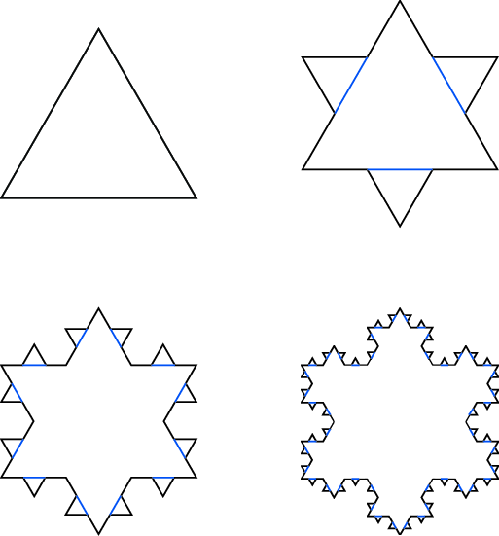
The figure below represents the an infinite process leading to a Jordan curve of infinite length known as Koch’s snowflake. As the iterations proceed, the area tends to a finite value (Figure 1).
Figure 1 Koch’s Snowflake progression
Assuming the initial triangle has length 1, its area is given by: $\sqrt{1^{2}-{\left(1/2\right)}^{2}}={\sqrt{3}}/4$. Adding the three additional triangles in the second iteration of side $1/3$, yields an area of ${\sqrt{3}}/4+3∙{\sqrt{3}}/4∙{\left(1/3\right)}^{2}={\sqrt{3}}/4\left(1+3/9\right)$. Continuing on and on, we get:
$$A=\frac{\sqrt{3}}{4}\left(1+\frac{3}{9}+\frac{3∙4}{9^{2}}+\frac{3∙4^{2}}{9^{3}}+…\right)=\frac{\sqrt{3}}{4}\left(1+\sum_{k=1}^{∞}{\frac{3∙4^{k-1}}{9^{k}}}\right)=\frac{\sqrt{3}}{4}∙\left(1+\frac{3/9}{1-4/9}\right)=\frac{2\sqrt{3}}{5}.$$
The length, $L$, of Koch’s snowflake grows by $4/3$ for each iteration: $L={\left(4/3\right)}^{n}→∞$ as $n→∞$.

Green’s Theorem on the Plane
Let $P\left(x,y\right)$ and $Q\left(x,y\right)$ be continuous with continuous partial derivatives in a simply or multiply connected region $R$ as well as on a boundary, $C$. Green’s theorem on the plane states:
e
f
g
h
$$\oint_{C}^{.}{Pdx+Qdy=∯_{R}^{.}{\left(Q_{x}-P_{y}\right)}}dxdy.$$
Proof:
$$∯_{R}^{.}{\frac{∂P}{∂y}dxdy}=\int_{x=e}^{x=f}{\left[\int_{y=Y_{1}\left(x\right)}^{y=Y_{2}\left(x\right)}{P\left(x,y\right)dy}\right]dx} \\ =\int_{x=e}^{x=f}{\left[P\left(x,Y_{2}\right)-P\left(x,Y_{1}\right)\right]dx}=-\int_{x=e}^{x=f}{P\left(x,Y_{1}\right)dx}-\int_{x=f}^{x=e}{P\left(x,Y_{1}\right)dx}=\oint_{C}^{.}{Pdx.}$$
Hence,
$\oint_{C}^{.}{Pdx=-∯_{R}^{.}{\frac{∂P}{∂y}dxdy }}and, similarly: \oint_{C}^{.}{Qdy=∯_{R}^{.}{\frac{∂Q}{∂x}dxdy}}. QED$

Example.
For the path show below:
$$y=x^{2}$$
$$y^{2}=x$$
$$\left(1,1\right)$$
$$\oint_{C}^{.}{\left(2xy-x^{2}\right)}dx+\oint_{C}^{.}{\left(x+y^{2}\right)}dy=\frac{1}{30}$$
$$\int_{0}^{1}{\left(2x\left(x^{2}\right)-x^{2}\right)dx}+\int_{0}^{1}{x+{\left(x^{2}\right)}^{2}d\left(x^{2}\right)}=\int_{0}^{1}{\left(2x^{3}-x^{2}\right)dx}+\int_{0}^{1}{\left(x+x^{4}\right)∙2xdx=\frac{7}{6}}$$
$$\int_{1}^{0}{\left(2\left(y^{2}\right)y-{\left(y^{2}\right)}^{2}\right)d\left(y^{2}\right)}+\int_{1}^{0}{y^{2}+y^{2}dy}=\int_{1}^{0}{\left(2y^{3}-y^{4}\right)∙2ydy}+\int_{1}^{0}{2y^{2}dy=-\frac{17}{15}}$$
The sum of the two integrals is $1/{30}.$ Applying Green’s Theorem on the plane, we have:
$$∯_{R}^{.}{\left(Q_{x}-P_{y}\right)}dxdy=\int_{x=0}^{x=1}{\int_{y=x^{2}}^{\sqrt{2}}{\left(1-2x\right)dxdy}}=\frac{1}{30}.$$

Aside – Green’s theorem generalizes in the theory of differential forms
Borrowing from electrodynamics, in three dimensions, for example, we have:
$$\int_{M}^{.}{\left(div B\right)dx^{1}∧dx^{2}∧dx^{3}=\int_{∂M}^{.}{B∙ds}}.$$
In two dimensions, we have:
$$\int_{disc}^{.}{curl A∙ds}=\int_{C}^{.}{A∙dl.}$$
In general: $\int_{M}^{.}{dω=\int_{∂M}^{.}{ω.}}$ That is: Integral of $\left(n+1\right)-form$ over a volume = integral of $n-$form over a surface (of dimension one less than volume).
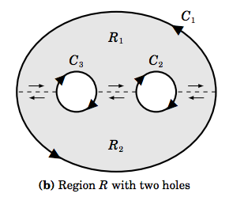
Green’s theorem works for multiply connected regions, $R=R_{1}+R_{2}$ and curves $C_{1}+C_{2}+C_{3}$:

Cauchy-Goursat Theorem
If a function, $f$, is analytic at all points interior to and on a simple closed contour $C$, i.e., $f$ is analytic on some simply connected domain$D$ containing $C$, then
$$\oint_{C}^{.}{f\left(z\right)dz=0}.$$
Proof. Since $f\left(z\right)=u+iv,$ recalling the divisor in the formal definition of the derivative: $Δx+iΔy,$
$$f^{'}\left(z\right)=u_{x}+{iv}_{x}=v_{y}-iv_{y}.$$
Therefore, as noted before: $u_{x}=v_{y} and u_{y}=-v_{x}.$
From Green’s Theorem on the Plane,
$$\oint_{C}^{.}{f\left(z\right)dz=}\oint_{C}^{.}{\left(u+iv\right)\left(dx+idy\right)}=\oint_{C}^{.}{udx-vdy}+i\oint_{C}^{.}{vdx+udy} \\ =∯_{D}^{.}{\left(-v_{x}-u_{y}\right)}dxdy+i∯_{D}^{.}{\left(u_{x}-v_{y}\right)}dxdy=0.$$
As before, this theorem can be extended to include multiply connected regions or domains.

Cauchy’s Integral Formulas
$$f^{\left(n\right)}\left(a\right)=\frac{n!}{2πi}\oint_{C}^{.}{\frac{f\left(z\right)}{{\left(z-a\right)}^{n+1}}}dz$$
taken over a simple, closed curve $C$ containing $a$ if $f\left(z\right)$ is known on $C$ and all of its derivatives can be found inside $C$.
Proof for the case $n=0$. Let $z=a+ϵe^{iθ}$ and $dz=iϵe^{iθ}dθ$ where $ϵ$ is small enough to stay inside $C$. Then as $ϵ→0$
$$\oint_{C}^{.}{\frac{f\left(z\right)}{z-a}}dz=\oint_{C}^{.}{\frac{f\left(a+ϵe^{iθ}\right)}{a+ϵe^{iθ}-a}}iϵe^{iθ}dθ=i\oint_{C}^{.}{\frac{f\left(a+ϵe^{iθ}\right)}{ϵe^{iθ}}}ϵe^{iθ}dθ=i\oint_{C}^{.}{f\left(a+ϵe^{iθ}\right)dθ→f\left(a\right)}$$
Proof for case $n=1$. Consider
$$f^{'}\left(a\right)=\lim_{h→0}\left(\frac{f\left(a+h\right)-f\left(a\right)}{h}\right) \\ =\lim_{h→0}\frac{1}{2πi}\oint_{C}^{.}{\left(\frac{z-a}{\left(\left(z-a\right)-h\right)\left(z-a\right)}-\frac{z-a-h}{\left(\left(z-a\right)-h\right)\left(z-a\right)}\right)}\frac{f\left(z\right)}{h}dz \\ =\lim_{h→0}\frac{1}{2πi}\oint_{C}^{.}{\frac{f\left(z\right)}{\left(z-a-h\right)\left(z-a\right)}}dz=\frac{1}{2πi}\oint_{C}^{.}{\frac{f\left(z\right)}{{\left(z-a\right)}^{2}}}dz.$$
This is equivalent to an extension of Leibnitz’ rule for differentiating under the integral sign:
$$\frac{d}{da}f\left(a\right)=\frac{d}{da}\left\{\frac{1}{2πi}\oint_{C}^{.}{\frac{f\left(z\right)}{z-a}}dz\right\}=\frac{1}{2πi}\oint_{C}^{.}{\frac{∂}{∂a}\left\{\frac{f\left(z\right)}{z-a}\right\} }dz.$$
Case for arbitrary $n$ follows by induction.

Consequences of Cauchy’s Integral Formula
- Morera’s Theorem is the converse of Cauchy’s theorem. If $f\left(z\right)$ is continuous in a simply-connected region $R$ and if $\oint_{C}^{.}{f\left(z\right)}dz=0$ around every simple closed curve $C$ in $R$, then$f\left(z\right)$ is analytic in $R$.
- Cauchy inequality – If $f\left(z\right)$ is analytic inside and on a circle $C$ of radius $r$ with center $z=a$, then
$$\left|f^{\left(n\right)}\left(a\right)\right|≤\frac{M∙n!}{r^{n}}, n=0,1,2…,$$
where $M$ is a positive constant such that $\left|f\left(z\right)\right|<M$ on $C$. (We’re in a bounded domain; an analytic function may be unbounded in a bounded domain.)
- Liouville’s Theorem. If for all $z$ in the entire complex plane including $∞$, (i) $f\left(z\right)$ is analytic and (ii) bounded, i.e., we can find a constant $M$ such that $\left|f\left(z\right)\right|<M$, then $f\left(z\right)$ must be constant.
Proof. Let $a$ and $b$ be any two points in the $z$ plane. Suppose $C$ is a circle or radius $r$ having center at $a$ and enclosing $b$. From Cauchy’s integral formula, we have
$$f\left(b\right)-f\left(a\right)=\frac{1}{2πi}\oint_{C}^{.}{\frac{f\left(z\right)}{z-b}}dz-\frac{1}{2πi}\oint_{C}^{.}{\frac{f\left(z\right)}{z-a}}dz=\frac{b-a}{2πi}\oint_{C}^{.}{\frac{f\left(z\right)}{\left(z-a\right)\left(z-b\right)}}dz.$$
With $\left|z-a\right|=r$, $\left|z-b\right|=\left|z-a+a-b\right|≥\left|z-a\right|-\left|a-b\right|=r-\left|a-b\right|≥r/2$ we may choose $r$ so large that $\left|a-b\right|<r/2.$ Then since $\left|f\left(z\right)\right|<M$ and the length of $C$ is $2πr$, we find
$$\left|f\left(b\right)-f\left(a\right)\right|=\frac{\left|b-a\right|}{2πi}\left|\oint_{C}^{.}{\frac{f\left(z\right)}{\left(z-a\right)\left(z-b\right)}}dz\right|≤\frac{\left|b-a\right|M2πr}{2π\left(r/2\right)r}=\frac{2\left|b-a\right|M}{r}.$$
As $r→∞$, $\left|f\left(b\right)-f\left(a\right)\right|→0$, or $f\left(b\right)=f\left(a\right)$. BEAUTIFUL!
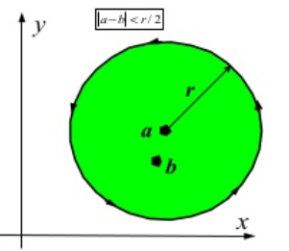
- Fundamental theorem of Algebra. Every polynomial equation $P\left(z\right)=a_{0}+a_{1}z+a_{z}z^{2}+…+a_{n}z^{n}=0$ where the degree $n≥1$ and $a_{n}≠0,$ has at least one root.
Proof. If $P\left(z\right)=0$ has no root, then $f\left(z\right)=1/{P\left(z\right)}$ is analytic for all $z.$ Also, $\left|f\left(z\right)\right|=\left|1/{P\left(z\right)}\right|$ is bounded (and approaches 0 as $\left|z\right|→∞$. From Liouville’s theorem, we must have that $f\left(z\right)$ must be constant, and therefore $P\left(z\right)$ is also constant. This contradicts the supposition that $P\left(z\right)$ is defined by a polynomial with degree $n≥1$ and $a_{n}≠0$ which is unbounded as $\left|z\right|→∞$. Hence $P\left(z\right)$ must have at least one root, or one zero.
- Corollary – The polynomial $P\left(z\right)$ has exactly $n$ zeros.
Proof. We know that $P\left(z\right)$ has at least one root, say, denoted by $α$. That is, $P\left(α\right)=0$. Hence
$$P\left(z\right)-P\left(α\right)=a_{0}+a_{1}z+a_{2}z^{2}+…+a_{n}z^{n}-\left(a_{0}+a_{1}α+a_{2}α^{2}+…+a_{n}α^{n}\right) \\ =a_{1}\left(z-α\right)+a_{2}\left(z^{2}-α^{2}\right)+…+a_{n}\left(z^{n}-α^{n}\right)=\left(z-α\right)Q\left(z\right)$$
where $Q\left(z\right)$ is a polynomial of degree $n-1$. By repeated application, we prove $P\left(z\right)$ has $n$ roots or zeros.
- Gauss’ mean value theorem. If $f\left(z\right)$ is analytic inside and on a circle $C$ of radius $r$ with center $z=a$, then $f\left(a\right)$ is the mean of the values of $f\left(z\right)$ on $C$, i.e.,
$$f\left(a\right)=\frac{1}{2π}\int_{0}^{2π}{f\left(a+re^{iθ}\right)}dθ.$$
Proof. Let $z=a+re^{iθ}$ such at $\left|z-a\right|=r$ and substitute into
$$f\left(a\right)=\frac{1}{2πi}\oint_{C}^{.}{\frac{f\left(z\right)}{z-a}}dz=\frac{1}{2π}\int_{0}^{2π}{f\left(a+re^{iθ}\right)}dθ.$$
- Maximum modulus theorem. If $f\left(z\right)$ is analytic inside and on a simple closed curve $C$, then the maximum value of $\left|f\left(z\right)\right|$ occurs on $C$, unless $f\left(z\right)$ is constant.
Proof. Given Gauss’ mean value theorem, we must have:
$$\left|f\left(a\right)\right|≤\frac{1}{2π}\int_{0}^{2π}{f\left|\left(a+re^{iθ}\right)\right|}dθ.$$
Suppose that $\left|f\left(a\right)\right|$ is a maximum such that $f\left|\left(a+re^{iθ}\right)\right|≤\left|f\left(a\right)\right|$. It this is so for one value of $θ$, then, by continuity, it would hold for some finite arc $θ_{1}<θ<θ_{2}$. But in such a case, the mean value of $f\left|\left(a+re^{iθ}\right)\right|$ is less than the mean value of $\left|f\left(a\right)\right|$, a contradiction of our integral above. Therefore, in any $δ$ neighborhood of $a$, i.e., $\left|z-a\right|<δ$, $f\left(z\right)$ must be a constant. If $f\left(z\right)$ is not a constant, the maximum value must occur on $C.$
- Minimum modulus theorem. Let $f\left(z\right)$ be analytic inside and on a simple closed curve $C.$ If $f\left(z\right)≠0$ inside $C$, then $\left|f\left(z\right)\right|$ must assume its minimum value on $C.$
Proof. Since $f\left(z\right)$ is analytic inside and on $C$ and since $\left(z\right)≠0$ inside $C$, it follows that $1/{f\left(z\right)}$ is analytic inside $C$. By the maximum modulus theorem, $1/{f\left(z\right)}$ cannot assume its maximum value inside $C$, therefore $f\left(z\right)$ cannot assume its minimum value inside $C$. Since $f\left(z\right)$ has a minimum, it must be on $C.$
- The argument theorem. Suppose $f\left(z\right)$ is analytic inside and on a simple closed curve $C$ except for a pole $z=α$ of order $p$ inside $C$. Suppose also that inside $C$, $f\left(z\right)$ has only one zero $z=β$ of order $n$ and no zeros on $C.$ Then,

$$\frac{1}{2πi}\oint_{C}^{.}{\frac{f^{'}\left(z\right)}{f\left(z\right)}}dz=n-p.$$
Let $C_{1}$ and $C_{2}$ be two non-overlapping circles lying inside $C$ and enclosing $z=α$ and $z=β$. See the figure below:
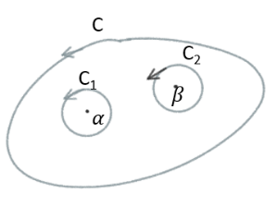
Then
$$\frac{1}{2πi}\oint_{C}^{.}{\frac{f^{'}\left(z\right)}{f\left(z\right)}}dz=\frac{1}{2πi}\oint_{C_{1}}^{.}{\frac{f^{'}\left(z\right)}{f\left(z\right)}}dz+\frac{1}{2πi}\oint_{C_{2}}^{.}{\frac{f^{'}\left(z\right)}{f\left(z\right)}}dz.$$

Since $f\left(z\right)$ has a pole of order $p$ at $z=α$, we have
$$f\left(z\right)=\frac{F\left(z\right)}{{\left(z-α\right)}^{p}}$$
where $F\left(z\right)$ is analytic and different from zero inside on and $C_{1}$. Taking logarithms we obtain

$$\ln{f\left(z\right)}=\ln{F\left(z\right)}-p\ln\left(z-α\right).$$
Differentiating, we get:
$$\frac{f^{'}\left(z\right)}{f\left(z\right)}=\frac{F^{'}\left(z\right)}{F\left(z\right)}-\frac{p}{z-a},$$
so that

$$\frac{1}{2πi}\oint_{C_{1}}^{.}{\frac{f^{'}\left(z\right)}{f\left(z\right)}}dz=\frac{1}{2πi}\oint_{C_{1}}^{.}{\frac{F^{'}\left(z\right)}{F\left(z\right)}}-\frac{p}{2πi}\oint_{C_{1}}^{.}{\frac{dz}{z-α}}=0-p=-p.$$
Since $f\left(z\right)$ has a zero of order $n$ inside $C_{2}$, we have $f\left(z\right)={\left(z-β\right)}^{n}G\left(z\right),$ where $G\left(z\right)$ is analytic and nonzero on $C_{2}.$ Then, but logarithmic differentiation (as above):
$$\frac{d}{dz}\ln{f\left(z\right)}=\frac{d}{dz}\left(n\ln\left(z-β\right)+\ln{G\left(z\right)}\right),$$
$$\frac{f'\left(z\right)}{f\left(z\right)}=\frac{n}{z-β}+\frac{G'\left(z\right)}{G\left(z\right)}.$$
Thus,
$$\frac{1}{2πi}\oint_{C_{2}}^{.}{\frac{f^{'}\left(z\right)}{f\left(z\right)}}dz=\frac{n}{2πi}\oint_{C_{2}}^{.}{\frac{dz}{z-β}}+\frac{1}{2πi}\oint_{C_{1}}^{.}{\frac{G^{'}\left(z\right)}{G\left(z\right)}}=n. QED$$

This theorem generalizes to $N-P$, these two positive integers being finitely many.

- Rouché’s Theorem. If $f\left(z\right)$ and $g\left(z\right)$ are analytic inside and on a simple closed curve $C$ and if $\left|g\left(z\right)\right|<\left|f\left(z\right)\right|$ on $C$, then $f\left(z\right)+g\left(z\right)$ and $f\left(z\right)$ have the same number of zeros inside $C$.
Let $F\left(z\right)={g\left(z\right)}/{f\left(z\right)}$ so that $g\left(z\right)=f\left(z\right)F\left(z\right)$, or, briefly, $g=fF$. If $N_{1}$ and $N_{2}$ are the number of zeros inside $C$ of $f+g$ and $f$ respectively, we have from a generalization of the argument theorem above,
$$N_{1}=\frac{1}{2πi}\oint_{C}^{.}{\frac{f^{'}+g'}{f+g}}dz, N_{2}=\frac{1}{2πi}\oint_{C}^{.}{\frac{f^{'}}{f}}dz,$$
Then
$$N_{1}-N_{2}=\frac{1}{2πi}\oint_{C}^{.}{\frac{f^{'}+g^{'}}{f+g}}dz-\frac{1}{2πi}\oint_{C}^{.}{\frac{f^{'}}{f}}dz \\ =\frac{1}{2πi}\oint_{C}^{.}{\frac{f^{'}+f^{'}F+fF^{'}}{f+fF}}dz-\frac{1}{2πi}\oint_{C}^{.}{\frac{f^{'}}{f}}dz \\ =\frac{1}{2πi}\oint_{C}^{.}{\frac{f^{'}\left(1+F\right)+fF^{'}}{f\left(1+F\right)}}dz-\frac{1}{2πi}\oint_{C}^{.}{\frac{f^{'}}{f}}dz \\ =\frac{1}{2πi}\oint_{C}^{.}{\left\{\frac{f^{'}}{f}+\frac{F^{'}}{1+F}\right\}dz}-\frac{1}{2πi}\oint_{C}^{.}{\frac{f^{'}}{f}}dz \\ =\frac{1}{2πi}\oint_{C}^{.}{\frac{F^{'}}{1+F}}dz \\ =\frac{1}{2πi}\oint_{C}^{.}{F'\left(1-F+F^{2}-F^{3}+…\right)}dz=0,$$
since $\left|F\right|<1$ on $C$ so that the series is uniformly convergent on $C$ and term by term integration yields the value of zero. Thus $N_{1}=N_{2}.$
Example using Rouché’s Theorem – Prove all roots of $z^{7}-5z^{3}+12$ lie between the circles $\left|z\right|=1$ and $\left|z\right|=2.$ Consider the circle $C_{1}: \left|z\right|=1$. Let $f\left(z\right)=12$ and $g\left(z\right)=z^{7}-5z^{3}$. On $C_{1}$ we have
$$\left|g\left(z\right)\right|=\left|z^{7}-5z^{3}\right|≤\left|z^{7}\right|+\left|5z^{3}\right|≤6<12=\left|f\left(z\right)\right|.$$
By Rouché’s Theorem, $f\left(z\right)+g\left(z\right)=z^{7}-5z^{3}+12$ has the same number of zeros inside $\left|z\right|=1$ as $f\left(z\right)=12$, and thus there are no zeros inside $C_{1}.$
Consider the circle $C_{2}:\left|z\right|=2.$ Let $f\left(z\right)=z^{7}$ and $g\left(z\right)=12-5z^{3}$. On $C_{2}$ we have
$$\left|g\left(z\right)\right|=\left|12-5z^{3}\right|≤\left|12\right|+\left|5z^{3}\right|≤60<2^{7}=\left|f\left(z\right)\right|.$$
By Rouché’s Theorem, $f\left(z\right)+g\left(z\right)=z^{7}-5z^{3}+12$ has the same number of roots inside $\left|z\right|=2$ as $f\left(z\right)=z^{7},$ i.e., all the zeroes are inside $C_{2}.$ Here they are:
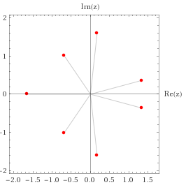

Poison’s integral formula for a circle – Used in potential theory and is connected to $SU\left(1,1\right)$ – Expresses the values of a harmonic function inside a circle in terms of its boundary values
This and Poisson’s integral formula for the half-plane are applied in the section below on Physical application of conformal mapping, specifically Dirichlet problems for the unit circle and for the half-plane.
In potential theory, the Poisson kernel is an integral kernel, used for solving the two-dimensional Laplace equation, given Dirichlet boundary conditions on the unit disk. It can be understood as the derivative of the Green's function for the Laplace equation $∇^{2}f=Δf=0$, named for Siméon Poisson.
Let $f\left(z\right)$ be analytic inside and on the circle C, $\left|z\right|=R$, and let $z=re^{iθ}$ be any point inside $C$. We show
$$f\left(re^{iθ}\right)=\frac{1}{2π}\int_{0}^{2π}{\frac{R^{2}-r^{2}}{R^{2}-2Rr\cos\left(θ-ϕ\right)+r^{2}}f\left(Re^{iθ}\right)dϕ}$$
Since $z=re^{iθ}$ is any point inside $C$, we have by Cauchy’s integral formula
$$f\left(z\right)=f\left(re^{iθ}\right)=\frac{1}{2π}\oint_{C}^{.}{\frac{f\left(w\right)}{w-z}dw}.$$
The inverse of the point $z$ with respect to $C$ lies outside $C$ and is defined by: ${R^{2}}/{\overline{z}}.$ Hence by Cauchy’s theorem (for a point outside $C$,
$$0=\frac{1}{2π}\oint_{C}^{.}{\frac{f\left(w\right)}{w-{R^{2}}/{\overline{z}}}dw.} \\ f\left(z\right)-0=\frac{1}{2πi}\oint_{C}^{.}{\left\{\frac{f\left(w\right)}{w-z}-\frac{f\left(w\right)}{w-{R^{2}}/{\overline{z}}}\right\}dw} \\ =\frac{1}{2πi}\oint_{C}^{.}{\left\{\frac{w-{R^{2}}/{\overline{z}}-w+z}{\left(w-z\right)\left(w-{R^{2}}/{\overline{z}}\right)}\right\}f\left(w\right)dw} \\ =\frac{1}{2πi}\oint_{C}^{.}{\left\{\frac{z-{R^{2}}/{\overline{z}}}{\left(w-z\right)\left(w-{R^{2}}/{\overline{z}}\right)}\right\}f\left(w\right)dw.}$$
Let $z=re^{iθ}$ and $w=Re^{iϕ}$. Since $\overline{z}=re^{-iθ}$, the integral becomes:
$$f\left(re^{iθ}\right)=\frac{1}{2πi}\int_{0}^{2π}{\frac{re^{iθ}-{R^{2}}/{re^{-iθ}}}{\left(Re^{iϕ}-re^{iθ}\right)\left(Re^{iϕ}-{R^{2}}/{re^{-iθ}}\right)}}f\left(Re^{iϕ}\right)Rie^{iϕ}dϕ \\ =\frac{1}{2π}\int_{0}^{2π}{\frac{\left(re^{iθ}-\left({R^{2}}/r\right)e^{iθ}\right)f\left(Re^{iϕ}\right)}{\left(Re^{iϕ}-re^{iθ}\right)\left(e^{iϕ}-\left(R/r\right)e^{iθ}\right)}}e^{iϕ}f\left(Re^{iϕ}\right)dϕ \\ =\frac{1}{2π}\int_{0}^{2π}{\frac{\left(r^{2}-R^{2}\right)e^{i\left(θ+ϕ\right)}f\left(Re^{iϕ}\right)}{\left(Re^{iϕ}-re^{iθ}\right)\left(re^{iϕ}-Re^{iθ}\right)}}f\left(Re^{iϕ}\right)dϕ \\ =\frac{1}{2π}\int_{0}^{2π}{\frac{\left(R^{2}-r^{2}\right)e^{i\left(θ+ϕ\right)}}{\left(Re^{iϕ}-re^{iθ}\right)\left(Re^{iθ}-re^{iϕ}\right)}\frac{e^{-i\left(θ+ϕ\right)}}{e^{-iθ}e^{-iϕ}}}f\left(Re^{iϕ}\right)dϕ \\ =\frac{1}{2π}\int_{0}^{2π}{\frac{\left(R^{2}-r^{2}\right)}{\left(Re^{iϕ}-re^{iθ}\right)\left(Re^{-iϕ}-re^{-iθ}\right)}}f\left(Re^{iϕ}\right)dϕ \\ =\frac{1}{2π}\int_{0}^{2π}{\frac{\left(R^{2}-r^{2}\right)f\left(Re^{iϕ}\right)}{R^{2}-Rre^{-i\left(θ-ϕ\right)}-Rre^{i\left(θ-ϕ\right)}+r^{2}}}dϕ \\ =\frac{1}{2π}\int_{0}^{2π}{\frac{\left(R^{2}-r^{2}\right)f\left(Re^{iϕ}\right)}{R^{2}-2Rr\cos\left(θ-ϕ\right)+r^{2}}}dϕ, QED.$$
Recall that we may write $f\left(re^{iθ}\right)=u\left(r,θ\right)+iv\left(r,θ\right).$

Poisson’s integral formulas for the half-plane
Let $C$ be the boundary of a semicircle of radius $R$ containing $ζ$as an interior point. Since $C$ encloses $ζ$but does not enclose $\overline{ζ}$, we have by Cauchy’s integral formula,
$$f\left(ζ\right)=\frac{1}{2πi}\oint_{C}^{.}{\frac{f\left(z\right)}{z-ζ}dz, 0=\frac{1}{2πi}\oint_{C}^{.}{\frac{f\left(z\right)}{z-\overline{ζ}}dz.}}$$
By subtraction,
$$f\left(ζ\right)=\frac{1}{2πi}\oint_{C}^{.}{f\left(z\right)\left\{\frac{1}{z-ζ}-\frac{1}{z-\overline{ζ}}\right\}}dz \\ =\frac{1}{2πi}\oint_{C}^{.}{\frac{\left(ζ-\overline{ζ}\right)f\left(z\right)}{\left(z-ζ\right)\left(z-\overline{ζ}\right)}}dz.$$
Let $ζ=ξ+iη, and \overline{ζ}=ξ-iη$, we can instead write
$$f\left(ζ\right)=\frac{1}{π}\int_{-R}^{R}{\frac{ηf\left(x\right)}{{\left(x-ξ\right)}^{2}+η^{2}}}dx+\frac{1}{π}\int_{Γ}^{R}{\frac{ηf\left(z\right)}{\left(z-ζ\right)\left(z-\overline{ζ}\right)}}dz,$$
where $Γ$ is the semicircular arc of $C$. As $R→∞$, the last integral tends to zero. Thus
$$f\left(ζ\right)=\frac{1}{π}\int_{-∞}^{∞}{\frac{ηf\left(x\right)}{{\left(x-ξ\right)}^{2}+η^{2}}}dx.$$
Writing $f\left(ζ\right)=f\left(ξ+iη\right)=u\left(ξ,η\right)+iv\left(ξ,η\right)$, and $f\left(x\right)=u\left(x,0\right)+iv\left(x,0\right),$ we obtain
$$u\left(ξ,η\right)=\frac{1}{π}\int_{-∞}^{∞}{\frac{ηu\left(x,0\right)}{{\left(x-ξ\right)}^{2}+η^{2}}}dx, v\left(ξ,η\right)=\frac{1}{π}\int_{-∞}^{∞}{\frac{ηv\left(x,0\right)}{{\left(x-ξ\right)}^{2}+η^{2}}}dx.$$

Example using Poisson’s integral formula for the half-plane
Solve the Dirichlet Problem in the upper half-plane $y>0$ subject to the boundary condition $ϕ\left(x,0\right)=f\left(x\right)=\cos{x}$from $-∞<x<∞$. After a lot of algebra and calculus, beginning with (by first substituting $s=t-x$ ) and
$$ϕ\left(x,y\right)=\frac{1}{π}\int_{-∞}^{∞}{\frac{yf\left(t\right)}{{\left(x-t\right)}^{2}+y^{2}}dt,}$$
the solution is:
$$ϕ\left(x,y\right)=e^{-y}\cos{x}.$$
To confirm, do ${∂^{2}ϕ}/{∂x^{2}+}{∂^{2}ϕ}/{∂y^{2}}$. You get $e^{-y}\cos{x+e^{-y}\cos{x=0.}}$

Neat problem
Consider
$$\int_{0}^{2π}{\cos^{2n}{θ}}dθ, n=1,2,3,…$$
Let $z=e^{iθ}$. Then $dz=ie^{iθ}dθ$, or $dθ={dz}/{iz}$ and $\cos{θ}=1/2\left(e^{iθ}+e^{-iθ}\right)=1/2\left(z+1/z\right)$. Hence, if $C$ is the unit circle $\left|z\right|=1$, we have
$$\oint_{C}^{.}{\cos^{2n}{θ}}dθ={\oint_{C}^{.}{\left\{\frac{1}{2}\left(z+\frac{1}{z}\right)\right\}}}^{2n}\frac{dz}{iz} =\frac{1}{2^{2n}i}\oint_{C}^{.}{\frac{1}{z}}\left\{z^{2n}+\left(\begin{matrix}2n \\ 1\end{matrix}\right)z^{2n-1}\frac{1}{z}+…+\left(\begin{matrix}2n \\ k\end{matrix}\right)z^{2n-k}{\left(\frac{1}{z}\right)}^{k}+…+{\left(\frac{1}{z}\right)}^{2n}\right\}dz=\frac{1}{2^{2n}i}\oint_{C}^{.}{\frac{1}{z}}\left\{z^{2n}+\left(\begin{matrix}2n \\ 1\end{matrix}\right)z^{2n-2}+…+\left(\begin{matrix}2n \\ k\end{matrix}\right)z^{2n-2k}+…+{\left(\frac{1}{z}\right)}^{2n}\right\}dz.$$The only nonzero term happens when $k=n$. Thus,
$$\oint_{C}^{.}{\cos^{2n}{θ}}dθ=\frac{1}{2^{2n}i}\left(\begin{matrix}2n \\ n\end{matrix}\right)2πi.$$
Now,
$$\left(\begin{matrix}2n \\ n\end{matrix}\right)=\frac{1}{n!}\left(1∙2∙3⋯2n\right) \\ =\frac{1}{n!}\left(2∙4∙6⋯2n\right)\left(1∙3⋯\left(2n-1\right)\right) \\ =\frac{1}{n!}\left(1∙2\right)\left(2∙2\right)\left(2∙3\right)⋯\left(2∙n\right)\left(1∙3⋯\left(2n-1\right)\right) \\ =\frac{2^{n}}{n!}n! \left(1∙3⋯\left(2n-1\right)\right) \\ =2^{n}\left(1∙3⋯\left(2n-1\right)\right)$$
So
$$\oint_{C}^{.}{\cos^{2n}{θ}}dθ=\frac{2^{n}}{2^{2n}i}2πi\left(1∙3⋯\left(2n-1\right)\right)=\frac{2π}{2^{n}}\left(1∙3⋯\left(2n-1\right)\right).$$

Cute – From ratio test: $\lim_{n→∞}{\frac{n^{n}}{\left(2n\right)!}}=0.$

Taylor’s Theorem
If $f\left(z\right)$ is analytic inside a circle $C$ with center $a$, then for all $z$ inside $C$
$$f\left(z\right)=f\left(a\right)+f^{'}\left(a\right)\left(z-a\right)+\frac{f^{''\left(a\right)}}{2!}{\left(z-a\right)}^{2}+\frac{f^{'''\left(a\right)}}{3!}{\left(z-a\right)}^{3}+…$$

Proof – Let $z$ be any point inside $C$. Construct a circle $C_{1}$ with center $a$ and enclosing $z$ (see the following figure).
w
C₁
C
z
a
Then by Cauchy’s integral formula, with $w$ taken along the circle $C_{1}$
$$f\left(z\right)=\frac{1}{2πi}\oint_{C}^{.}{\frac{f\left(w\right)}{w-z}}dw$$
we have
$$\frac{1}{w-z}=\frac{1}{\left(w-a\right)-\left(z-a\right)}=\frac{1}{w-a}\left\{\frac{1}{1-{\left(z-a\right)}/{w-a}}\right\} \\ =\frac{1}{w-a}\left\{1+\left(\frac{z-a}{w-a}\right)+{\left(\frac{z-a}{w-a}\right)}^{2}+…+{\left(\frac{z-a}{w-a}\right)}^{n-1}+{\left(\frac{z-a}{w-a}\right)}^{n}\frac{1}{1-{\left(z-a\right)}/{w-a}}\right\} \\ =\frac{1}{w-a}+\frac{z-a}{{\left(w-a\right)}^{2}}+\frac{{\left(z-a\right)}^{2}}{{\left(w-a\right)}^{3}}+\frac{{\left(z-a\right)}^{4}}{{\left(w-a\right)}^{4}}+…\frac{{\left(z-a\right)}^{n-1}}{{\left(w-a\right)}^{n}}+{\left(\frac{z-a}{w-a}\right)}^{n}\frac{1}{w-z}.$$
Multiply both sides by $f\left(w\right)$ and use Cauchy’s integral formula:
$$f\left(z\right)=\frac{1}{2πi}\oint_{C}^{.}{\frac{f\left(w\right)}{w-z}}dw+\frac{z-a}{2πi }\oint_{C}^{.}{\frac{f\left(w\right)}{{\left(w-z\right)}^{2}}}dw+…+\frac{{\left(z-a\right)}^{n-1}}{2πi }\oint_{C}^{.}{\frac{f\left(w\right)}{{\left(w-z\right)}^{n}}}dw+U_{n}$$
where
$$U_{n}=\frac{1}{2πi}\oint_{C}^{.}{{\left(\frac{z-a}{w-a}\right)}^{n}\frac{f\left(w\right)}{w-z}}dw.$$
Recalling Cauchy’s integral formulas:
$$f^{\left(n\right)}\left(a\right)=\frac{n!}{2πi}\oint_{C}^{.}{\frac{f\left(z\right)}{{\left(z-a\right)}^{n+1}}}dz$$
we have:
$$f\left(z\right)=f\left(a\right)+f^{'}\left(a\right)\left(z-a\right)+\frac{f^{''}\left(a\right)}{2!}{\left(z-a\right)}^{2}+\frac{f^{'''}\left(a\right)}{3!}{\left(z-a\right)}^{3}+…+\frac{f^{\left(n-1\right)}}{\left(n-1\right)!}{\left(z-a\right)}^{n-1}+U_{n}.$$
We show $U_{n}→0$ as $n→∞$. Note that since $w$ is on $C_{1}$,
$$\left|\frac{z-a}{w-a}\right|=γ<1$$
where $γ$ is a constant. Also $\left|f\left(w\right)\right|<M$ where $M$is a constant, and, with $r_{1}$ the radius of $C_{1},$
$$\left|w-z\right|=\left|\left(w-a\right)-\left(a-w\right)\right|≥r_{1}-\left|z-a\right|.$$
Hence,
$$\left|U_{n}\right|=\frac{1}{2π}\left|\oint_{C}^{.}{{\left(\frac{z-a}{w-a}\right)}^{n}\frac{f\left(w\right)}{w-z}}dw\right|≤\frac{1}{2π}\frac{γ^{n}M}{r_{1}-\left|z-a\right|}$$
and $\lim_{n→∞}{U_{n}}=0.$

Laurent’s Theorem
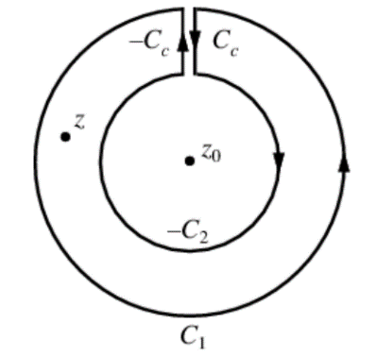
If $f\left(z\right)$ is analytic inside and on the boundary of the ring shaped region bounded by two concentric circles $C_{1}$ and $C_{2}$ with center at $z_{0}$ and respective radii $r_{1}$ and $r_{2}$ with $r_{1}>r_{2},$ then for all $z$ in $R,$
$$f\left(z\right)=\sum_{n=0}^{∞}{a_{n}{\left(z-z_{0}\right)}^{n}+\sum_{n=0}^{∞}{\frac{a_{n}}{{\left(z-z_{0}\right)}^{n}}}}$$
where
$$a_{n}=\frac{1}{2πi}\oint_{C}^{.}{\frac{f\left(w\right)}{{\left(w-z_{0}\right)}^{n+1}}}dw, n=0,1,2,…, and a_{n}=\frac{1}{2πi}\oint_{C}^{.}{\frac{f\left(w\right)}{{\left(w-z_{0}\right)}^{-n+1}}}dw, n=1,2,3,…$$
By Cauchy’s integral formula,
$$f\left(z\right)=\frac{1}{2πi}\oint_{C_{1}}^{.}{\frac{f\left(w\right)}{w-z}}dw-\frac{1}{2πi}\oint_{C_{2}}^{.}{\frac{f\left(w\right)}{w-z}}dw.$$
The first integral gives the Taylor series portion which we have treated in the previous section. Consider
$$-\frac{1}{w-z}=\frac{1}{\left(z-z_{0}\right)\left\{1-{\left(z-z_{0}\right)}/{w-z_{0}}\right\}} \\ =\frac{1}{z-z_{0}}+\frac{w-z_{0}}{{\left(z-z_{0}\right)}^{2}}+⋯+\frac{{\left(w-z_{0}\right)}^{n-1}}{{\left(z-z_{0}\right)}^{n}}+{\left(\frac{w-z_{0}}{z-z_{0}}\right)}^{n}\frac{1}{w-z}.$$
So that,
$$-\frac{1}{2πi}\oint_{C_{2}}^{.}{\frac{f\left(w\right)}{w-z}}dw=\frac{1}{2πi}\oint_{C_{2}}^{.}{\frac{f\left(w\right)}{z-z_{0}}}dw+\frac{1}{2πi}\oint_{C_{2}}^{.}{\frac{w-z_{0}}{{\left(z-z_{0}\right)}^{2}}f\left(w\right)}dw+⋯+\frac{1}{2πi}\oint_{C_{2}}^{.}{\frac{{\left(w-z_{0}\right)}^{n-1}}{{\left(z-z_{0}\right)}^{n}}f\left(w\right)}dw+V_{n} \\ =\frac{a_{-1}}{z-z_{0}}+\frac{a_{-2}}{{\left(z-z_{0}\right)}^{2}}+⋯\frac{a_{-n}}{{\left(z-z_{0}\right)}^{n}}+V_{n},$$
where
$$a_{-1}=\frac{1}{2πi}\oint_{C_{2}}^{.}{f\left(w\right)}dw, a_{-2}=\frac{1}{2πi}\oint_{C_{2}}^{.}{\left(w-z_{0}\right)f\left(w\right)}dw,…, a_{-n}=\frac{1}{2πi}\oint_{C_{2}}^{.}{{\left(w-z_{0}\right)}^{n-1}f\left(w\right)}dw and V_{n}=\frac{1}{2πi}\oint_{C_{2}}^{.}{{\left(\frac{w-z_{0}}{z-z_{0}}\right)}^{n}\frac{f\left(w\right)}{z-w}}dw.$$
To show $V_{n}→0$ as $n→0$ note that since $w$ is on $C_{2}$
$$\left|\frac{w-z_{0}}{z-z_{0}}\right|=κ<1,$$
where $κ$ is a constant. Also, we have $\left|f\left(w\right)\right|<M$ where $M$ is a constant and
$$\left|z-w\right|=\left|\left(z-z_{0}\right)-\left({w-z}_{0}\right)\right|≥\left|z-a\right|-r_{2}.$$
This is an identical set of conditions as we showed for $U_{n}$, so $V_{n}→0.$ The series terms starting with $a_{0}$ and having positive powers are the analytic part, while those with inverse powers of $\left|z-a\right|$ is the principle part.

Classification of singularities
It is possible to classify the singularities of a function $f\left(z\right)$ by examining its Laurent series. We consider the figure below:
w
C₁
C
z
a
In this case, $f\left(z\right)$ is analytic inside and on $C$ except at $z=a$, which is an isolated singularity. We assume all singularities to be isolated singularities.

Poles
If $f\left(z\right)$ has the form
$$f\left(z\right)=a_{0}+a_{1}\left(z-a\right)+a_{2}{\left(z-a\right)}^{2}+…+\frac{a_{-1}}{\left(z-a\right)}+\frac{a_{-2}}{{\left(z-a\right)}^{2}}+…$$
in which the principle part has only a finite number of terms given by
$$\frac{a_{-1}}{\left(z-a\right)}+\frac{a_{-2}}{{\left(z-a\right)}^{2}}+…+\frac{a_{-n}}{{\left(z-a\right)}^{n}}$$
where $a_{-n}≠0$, then $z=a$ is a pole of order $n.$

Removable singularities
If a single-valued function $f\left(z\right)$ is not defined at $z=a$ but $\lim_{z→a}{f\left(z\right)}$ exists, then $z=a$ is called a removable singularity. In such cases, we equate $f\left(z\right)$ at $z=a$ to $\lim_{z→a}{f\left(z\right)}$,

Example
If $f\left(z\right)={\sin{z}}/z$, then $z=0$ is a removable singularity since $f\left(0\right)=\lim_{z→0}{{\sin{z}}/z}=1$. Note that in this case
$$\frac{\sin{z}}{z}=\frac{1}{z}\left\{z-\frac{z^{3}}{3!}+\frac{z^{5}}{5!}-\frac{z^{7}}{7!}+…\right\}=1-\frac{z^{2}}{3!}+\frac{z^{4}}{5!}-\frac{z^{6}}{7!}+…$$

Essential singularities
If $f\left(z\right)$ is single-valued, then any singularity which is not a pole or removable singularity is called an essential singularity. If $z=a$ is an essential singularity of $f\left(z\right)$, the principle part of the Laurent series has infinitely many terms.

Example
Since
$$e^{1/z}=1+\frac{1}{z}+\frac{1}{2!z^{2}}+\frac{1}{3!z^{3}}+…$$
then $z=0$ is an essential singularity.

Casorai-Weierstrass theorem
In any neighborhood of an isolated essential singularity $a$, an otherwise analytic function $f\left(z\right)$ comes arbitrarily close to any complex number $A$. That is given any positive numbers $δ$ and $ϵ$ and any complex number $A$, there exists a value of $z$ inside the cir le $\left|z-a\right|=δ$ for which $\left|f\left(z\right)-A\right|<ϵ$. No proof is offered.

Picard’s Theorem
In the neighborhood of an isolated essential singularity $a$, an otherwise analytic function $f\left(z\right)$ can take on any value whatsoever with perhaps one exception. No proof is offered.

Branch points
Suppose we are given the function $w=z^{1/2}.$ Suppose further that we allow $z$ to make a complete circuit (counterclockwise) around the origin starting at $A$, say, in quadrant 1. We have on our path, $z=re^{iθ},$ $w=\sqrt{r}e^{{iθ}/2}$ so that at $A$, $θ=θ_{1}$ and $w=\sqrt{r}e^{{iθ_{1}}/2}$. After a complete circuit back to $A$, i.e., $θ=θ_{1}+2π$ and $w=\sqrt{r}e^{{i\left(θ+2π\right)}/2}=-\sqrt{r}e^{{iθ}/2}$ since $e^{iπ}=-1$. The counterclockwise circuit changed the value of our function. We can return to the value of our function after two counterclockwise rotations with $θ=θ_{1}+4π$.
We say that if $0≤θ≤2π$ we are on one branch of the multivalued function $z^{1/2}$, while if $2π≤θ≤4π$ we are on the other branch of the function.
A point $z=z_{0}$ is called a branch point of the multiple-valued function $f\left(z\right)$ if the branches of $f\left(z\right)$ are interchanged when $z$ describes a closed path about $z_{0}$. Since each of the branches of a multiple-valued function is analytic, all of the theorems for analytic functions, in particular, Taylor’s theorem, apply.

Singularities at infinity
By letting $z=1/w$ in $f\left(z\right)$, we obtain the function $f\left(1/w\right)=F\left(w\right)$. Then the nature of the singularity at $z=∞$ (the point at infinity) is defined to be the same as that of $F\left(w\right)$ at $w=0$.

Example
$f\left(z\right)=z^{3}$ has a pole of order 3 at $z=∞$ since $F\left(w\right)=f\left(1/w\right)=1/{w^{3}}$ has a pole of order 3 at $z=0$. Similarly, $f\left(z\right)=e^{z}$ has an essential singularity at $z=∞$ since $\left(w\right)=f\left(1/w\right)=e^{\left(1/2\right)}$ has an essential singularity at $w=0$.

Entire functions
A function which is analytic everywhere in the finite plane, i.e., everywhere except at $∞$, is called an entire function or integral function. The functions $e^{z}$, $\sin{z},$ $\cos{z}$ are entire functions.
An entire function can be represented by a Taylor series with an infinite radius of convergence, and conversely. Recall that by Liouville’s theorem, a function which is analytic everywhere including $∞$ is constant.

Meromorphic functions
A function which is analytic everywhere in the finite plane except at a finite number of poles is called a meromorphic function.

Examples of Laurent Series

Consider
$$\frac{e^{2z}}{{\left(z-1\right)}^{3}}, z=1$$
Let $z-1=u$, or $z=1+u.$
$$\frac{e^{2z}}{{\left(z-1\right)}^{3}}=\frac{e^{2u+2}}{u^{3}}=\frac{e^{2}}{u^{3}}e^{2u}=\frac{e^{2}}{u^{3}}\left(1+2u+\frac{{\left(2u\right)}^{2}}{2!}+\frac{{\left(2u\right)}^{3}}{3!}+…\right)=\frac{e^{2}}{{\left(z-1\right)}^{3}}+\frac{{2e}^{2}}{{\left(z-1\right)}^{2}}+\frac{{2e}^{2}}{z-1}+\frac{4e^{2}}{3}\left(z-1\right)+…$$
Thus $z=1$ is a pole of order 3. (The bolded term is the residue $a_{-1}.)$

Consider
$$\left(z-3\right)\sin{\frac{1}{z+2}, z=-2}.$$
Let $z+2=u, z=u-2.$
$$\left(z-3\right)\sin{\frac{1}{z+2}=\left(u-5\right)\sin{\frac{1}{u}}}= \left(u-5\right)\left\{\frac{1}{u}-\frac{1}{3!u^{3}}+\frac{1}{5!u^{5}}-…\right\} \\ =1-\frac{5}{u}-\frac{1}{3!u^{3}}+\frac{5}{3!u^{3}}+\frac{1}{5!u^{5}}-… \\ =1-\frac{5}{z-(-2)}+\frac{1}{6{\left(z+2\right)}^{2}}+\frac{5}{6{\left(z+2\right)}^{3}}+\frac{1}{120{\left(z+2\right)}^{4}}-…$$
Thus $z=-2$ is an essential singularity. The Laurent series converges for every $z≠2$.

Consider
$$\frac{z-\sin{z}}{z^{3}}, z=0$$
$$\frac{z-\sin{z}}{z^{3}}=\frac{1}{z^{3}}\left\{z-\left(z-\frac{z^{3}}{3!}+\frac{z^{5}}{5!}-\frac{z^{7}}{7!}+…\right)\right\}=\frac{1}{z^{3}}\left\{\frac{z^{3}}{3!}-\frac{z^{5}}{5!}+\frac{z^{7}}{7!}-…\right\}=\frac{1}{3!}-\frac{z^{2}}{5!}+\frac{z^{4}}{7!}-…$$
Thus $z=0$ is a removable singularity.

Consider
$$\frac{z}{\left(z+3\right)\left(z+2 \right)}=, z=-2$$
Let $z+2=u.$
$$\frac{z}{\left(z+3\right)\left(z+2 \right)}=\frac{u-2}{\left(u-1\right)u} \\ =\frac{2-u}{u}∙\frac{1}{1-u} \\ =\frac{2-u}{u}\left(1+u+u^{2}+u^{3}+…\right) \\ =\frac{2}{u}+1+u+u^{2}+… \\ =\frac{2}{z-(-2)}+1+\left(z+2\right)+{\left(z+2\right)}^{2}+…$$
Thus $z=-2$ is a pole of order 1. The Laurent series converges for $0<\left|z+2\right|<1.$

Consider
$$\frac{1}{z^{2}{\left(z-3\right)}^{2}}, z=3$$
Let $z-3=u.$
$$\frac{1}{z^{2}{\left(z-3\right)}^{2}}=\frac{1}{u^{2}{\left(3+u\right)}^{2}} \\ =\frac{1}{9u^{2}{\left(1+\frac{u}{3}\right)}^{2}} \\ =\frac{1}{9u^{2}}\left\{1+\left(-2\right)\left(\frac{u}{3}\right)+\frac{\left(-2\right)\left(-1\right)}{2!}{\left(\frac{u}{3}\right)}^{2}+\frac{\left(-2\right)\left(-3\right)\left(-4\right)}{3!}{\left(\frac{u}{3}\right)}^{3}+…\right\} \\ =\frac{1}{9u^{2}}-\frac{2}{27u}+\frac{1}{27}-\frac{4}{243}u+… \\ =\frac{1}{9{\left(z-3\right)}^{2}}-\frac{2}{27\left(z-3\right)}+\frac{1}{27}-\frac{4\left(z-3\right)}{243}+…$$
The Laurent series converges for every $z$ in $0<\left|z-3\right|<3.$

Lagrange inversion theorem—Cool link
The Lagrange inversion theorem (or Lagrange inversion formula), also known as the Lagrange--Bürmann formula, gives the Taylor series expansion of the inverse function of an analytic function. There are many generalizations of Lagrange inversion. The Lagrange inversion formula is one of the fundamental formulas of combinatorics. Among other problems, the Lagrange Inversion Theorem allows us to find the roots of any polynomial in terms of infinite series, as opposed to radical extension, which ceases to work for polynomials of order 5 or above as Galois showed using group theory. Please refer to Oeuvres de Lagrange, PUBLIÉES PAR LES SOINS DE M. J. -A. SERRET, SOUS LES AUSPICE DE SON EXCELLENCE, LE MINISTRE DE L'INSTRUCTION PUBLIQUE, TOME TROISIÈME, PARIS, GAUTHIER-VILLARS, IMPRIMEUR-LIBRAIRE DE L'ÉCOLE IMPÉRIALE POLYTECHNIQUE, DU BUREAU DES LONGITUDES, MDCCCLXIX (1869).

Analytic Continuation
Example will follow after the verbiage. Suppose we do not know the form of an analytic function $f\left(z\right)$ but know that inside some circle of convergence $C_{1}$ with center at $a$, $f\left(z\right)$ is represented by a Taylor series: $f\left(z\right)=a_{0}+a_{1}\left(z-a\right)+a_{2}{\left(z-a\right)}^{2}+…$
Choosing a point $b$ inside $C_{1}$, we can find the value of $f\left(z\right)$ and its derivatives at $b$ from our Taylor series above to obtain: $f\left(z\right)=b_{0}+b_{1}\left(z-a\right)+b_{2}{\left(z-a\right)}^{2}+…$
having a circle of convergence $C_{2}.$ If $C_{2}$ extends beyond $C_{1}$, then the values of $f\left(z\right)$ and its derivatives can be obtained in this extended portion, obtaining more information concerning $f\left(z\right).$
We say that $f\left(z\right)$ has been extended analytically beyond $C_{1}$ and call the process analytic continuation or analytic extension.
The process can be repeated indefinitely. The collection of all such power series (all possible analytic continuations) is defined as the analytic function $f\left(z\right)$ and each power series is sometimes called an element of $f\left(z\right)$.
The process of analytic continuation must avoid singularities. From our discussion above, there cannot be any singularity which is both inside $C_{2}$ and on the boundary of $C_{1}$. In some cases, the singularities on a circle of convergence are so numerous that analytic continuation is impossible. In these cases, the boundary of the circle of is called a natural boundary or barrier. The function represented by a series having a natural boundary is called a lacunary function.
(lacunary - having gaps or missing portions. E.g., "the lacunary nature of recollected experience")

Example
Show that
$$\sum_{n=0}^{∞}{\frac{z^{n}}{2^{n+1}} and }\sum_{n=0}^{∞}{\frac{{\left(z-i\right)}^{n}}{{\left(2-i\right)}^{n+1}}}$$
are analytic continuations of each other.
Concerning the first series, by the ratio test,
$$\frac{z^{n+1}}{2^{n+2}}∙\frac{2^{n+1}}{z^{n}}=\frac{z^{n}}{2}.$$
we see that the series converges for $\left|z\right|<2$. In this circle the series (a geometric series, with first term $1/2$ and ratio $z/2,$ can be summed and represents the function
$$f\left(z\right)=\frac{1/2}{1-z/2}=\frac{1}{2-z}.$$
Concerning the second series, by the ratio test
$$\left|\frac{{\left(z-i\right)}^{n+1}}{{\left(2-i\right)}^{n+2}}∙\frac{{\left(2-i\right)}^{n+1}}{{\left(z-i\right)}^{n}}\right|=\left|\frac{z-i}{2-i}\right|$$
convergence happens when
$$\left|\frac{z-i}{2-i}\right|<1,$$
or
$$\left|z-1\right|<\left|2-i\right|={\left(2^{2}+1^{2}\right)}^{1/2}=5.$$
In this circle the series (which is a geometric series with first term $1/{\left(2-i\right)}$ and ratio ${\left(z-i\right)}/{\left(2-i\right)}$ can be summed and represents the function
$$f\left(z\right)=\frac{1/{\left(2-i\right)}}{1-{\left(z-i\right)}/{\left(2-i\right)}}=\frac{1}{2-z}.$$
Since the power series represent the same function to the interiors of the circles $\left|z\right|<2$ and $\left|z-i\right|<5$, it follows that they are analytic continuations of each other.
x
y
i
$$2$$
$$\sqrt{5}$$
By this ‘method’, then, say,
$$\frac{1}{\left(2-2i\right)\left(1-{\left(z-2i\right)}/{\left(2-i\right)}\right)}=\frac{1}{2-z}=\frac{1/{\left(2-2i\right)}}{1-{\left(z-2i\right)}/{\left(2-2i\right)}}=\sum_{n=0}^{∞}{\frac{{\left(z-2i\right)}^{n}}{{\left(2-2i\right)}^{n+1}}}$$
is an analytic continuation with radius of convergence given by employing the ratio test.

Residues
Let $f\left(z\right)$ be single-valued and analytic inside and on a circle $C$ except at the point $z=a$ chosen at the center of $C$. Then as we have seen, $f\left(z\right)$ has a Laurent series about $z=a$ given by
$$f\left(z\right)=\sum_{n=-∞}^{∞}{a_{n}{\left(z-a\right)}^{n}} \\ =a_{0}+a_{1}\left(z-a\right)+a_{2}{\left(z-a\right)}^{2}+…+\frac{a_{-1}}{\left(z-a\right)}+\frac{a_{-2}}{{\left(z-a\right)}^{2}}+…$$
where
$$a_{n}=\frac{1}{2πi}\oint_{C}^{.}{\frac{f\left(z\right)}{{\left(z-a\right)}^{n+1}}}dz, n=0,±1,±2,…$$
In the special case of $n=-1$ we have
$$\oint_{C}^{.}{f\left(z\right)}dz=2πia_{-1}.$$
Recall that:
$$\oint_{C}^{.}{\frac{f\left(z\right)}{\left(z-a\right)}}dz=\oint_{C}^{.}{\frac{f\left(a+ϵe^{iθ}\right)}{a+ϵe^{iθ}-a}}iϵe^{iθ}dθ=i\oint_{C}^{.}{\frac{f\left(a+ϵe^{iθ}\right)}{ϵe^{iθ}}}ϵe^{iθ}dθ=i\oint_{C}^{.}{f\left(a+ϵe^{iθ}\right)dθ→f\left(a\right)}$$
So, with $f\left(z\right)=1,$
$$\oint_{C}^{.}{\frac{f\left(z\right)}{{\left(z-a\right)}^{p}}}dz=\left\{\begin{matrix}2πi p=1 \\ 0 p≠1\end{matrix}\right\}.$$

Calculations of residues
To obtain the residue of $f\left(z\right)$ at $z=a$ we need to obtain the Laurent series. However, in the case where $z=a$ is a pole of order $k$, there is a simple formula for $a_{-1}$ given by
$$a_{-1}=\lim_{z→a}{\frac{1}{\left(k-1\right)!}}\frac{d^{k-1}}{dz^{k-1}}\left\{{\left(z-a\right)}^{k}f\left(z\right)\right\}.$$

Example
If
$$f\left(z\right)=\frac{z}{\left(z-1\right){\left(z+1\right)}^{2}}$$
then $z=1,-1$ are poles of orders one and two, respectively. We have,
Reside ($z=1$): $a_{-1}=\lim_{z→1}\left(z-1\right)\left\{\frac{z}{\left(z-1\right){\left(z+1\right)}^{2}}\right\}=\frac{1}{4}.$
Reside (z = -1): $a_{-1}=\lim_{z→-1}{\frac{1}{1!}\frac{d}{dz}}\left\{{\left(z+1\right)}^{2}\left(\frac{z}{\left(z-1\right){\left(z+1\right)}^{2}}\right)\right\}=-\frac{1}{4}.$

Residue Theorem
So, depending on the curve we integrate on, we know the residues, and hence the possible values of
$$\oint_{C}^{.}{\frac{f\left(z\right)}{z-a}}dz=2πi\sum_{residues}{a_{-1}}.$$
If $z=a$ is an essential singularity, the residue can sometimes be found by using known series expansions.

Example
If $f\left(z\right)=e^{{-1}/z}$, then $z=0$ is an essential singularity and from the known expansion for $e^{u}$ with $u={-1}/z$, we find
$$e^{-\frac{1}{z}}=1-\frac{1}{z}+\frac{1}{2!z^{2}}-\frac{1}{3!z^{3}}+…$$from which we see that the residue at $z=0$ is the coefficient of $\frac{1}{z}$ and equals -1.

Evaluation of integrals
The evaluation of definite integrals is often achieved by using the residue theorem together with a suitable function $f\left(z\right)$ and a suitable closed path or contour $C$, the choice of which may require great ingenuity.
Consider $\int_{-∞}^{∞}{F\left(x\right)dx}$ where $F\left(x\right)$ is a rational function and it is an even function. Then consider $\oint_{C}^{.}{F\left(z\right)}dz$ along the contour: the line along the $x$ axis from $-R$ to $R$ and the semicircle above the $x$ axis have this line as its diameter. Then let $R→∞$.

Example
With the contour as defined above, consider the integral of the even, rational function below:
$$\int_{-∞}^{∞}{\frac{x^{2}}{\left(x^{2}+1\right)\left(x^{2}+2x+2\right)}}dx$$
The poles are $z=i$ of order 2 and $z=-1+i$ of order 1.
The residue at $z=i$ is
$$a_{-1}=\lim_{z→i}{\frac{d}{dz}}\left\{{\left(z-i\right)}^{2}\frac{z^{2}}{{\left(z-i\right)}^{2}\left(z^{2}+2z+2\right)}\right\}=\frac{9i-12}{100}.$$
The residue at $z=-1+i$ is
$$a_{-1}=\lim_{z→-1+i}\left(z+1-i\right)\frac{z^{2}}{{\left(z+i\right)}^{2}\left(z+1-i\right)\left(z+1+i\right)}=\frac{3-4i}{25}.$$
From the residue theorem, the above integral equals ${7π}/{50}$.

Integrals of $G\left(\sin{θ,}\cos{θ}\right)$
If the function $G\left(\sin{θ,}\cos{θ}\right)$ is a rational function of $\sin{θ}$ and $\cos{θ}$, let $z=e^{iθ}$. With
$$\sin{θ=\frac{z-z^{-1}}{2i}}, \cos{θ}=\frac{z+z^{-1}}{2},$$
the integral is equivalent to $\oint_{C}^{.}{F\left(z\right)}dz$.

Integrals of $\int_{-∞}^{∞}{F\left(x\right)\left\{\begin{matrix}\cos{mx} \\ \sin{mx}\end{matrix}\right\}dx}, F\left(x\right)$ rational
Consider $\oint_{C}^{.}{F\left(z\right)}e^{imz}dz$ with the upper halfplane semicircle contour as $R→∞.$
The theory continues.

Conformal Mapping

Transformations or mappings
The following equations are a transformation or mapping between points on the $uv$ plane and the $xy$ plane. If the mapping is one-to-one, the two planes are said to be images of each other.
$$u=u\left(x,y\right), v=v\left(x,y\right)$$

Jacobian of a transformation
Under the above transformation, a closed region $R$ of the $xy$ plane is in general mapped to a closed region $R'$ of the $uv$ plane. If $ΔA_{xy}$ and $ΔA_{uv}$ are the respective areas of the regions, we can show that if $u$ and $v$ are continuously differentiable,
$$\lim{\frac{ΔA_{uv}}{ΔA_{xy}}}= \left|\frac{∂\left(u,v\right)}{∂\left(x,y\right)}\right|, where$$
$$\frac{∂\left(u,v\right)}{∂\left(x,y\right)}=\left|\begin{matrix}\frac{∂u}{∂x} & \frac{∂u}{∂y} \\ \frac{∂v}{∂x} & \frac{∂v}{∂y} \end{matrix}\right|=\frac{∂u}{∂x}\frac{∂v}{∂y }-\frac{∂u}{∂y}\frac{∂v}{∂x }$$
is the Jacobian of the transformation. If the Jacobian is invertible (nonzero) and $u$ and $v$ are continuously differentiable, then we can find the inverse transformation $x=x\left(u,v\right)$ and $y=y\left(u,v\right).$

Complex mapping functions
A special case occurs when $u$ and $v$ are the real and imaginary parts of an analytic function of a complex variable $z=x+iy$, i.e., $w=u+iv=f\left(z\right)=f\left(x+iy\right)$. In such case, the Jacobian is given by
$$\frac{∂\left(u,v\right)}{∂\left(x,y\right)}={\left|f^{'}\left(z\right)\right|}^{2}.$$
The transformation is one-to-one where $f'\left(z\right)≠0$. Points where $f^{'\left(z\right)}=0$ are called critical points.

Conformal mapping
Suppose under our transformation $u=u\left(x,y\right)$ and $v=v\left(x,y\right)$ the point $\left(x_{0},y_{0}\right)$ of the $xy$ plane is mapped to the point $\left(u_{0},v_{0}\right)$ of the $uv$ plane while curves $C_{1}$ and $C_{2}$ (intersecting at $\left(x_{0},y_{0}\right)$) are mapped to $C_{1}'$ and $C_{2}'$ (intersecting at $\left(u_{0},v_{0}\right)$. If the angle between $C_{1}$ and $C_{2}$ remains the same as the angle between $C_{1}'$ and $C_{2}'$, the transformation is said to be conformal. (A mapping which preserves the magnitudes of angles but not their sense is called isogonal.)
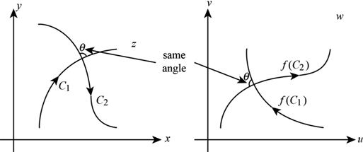
Theorem – If $f\left(z\right)$ is analytic and $f'\left(z\right)≠0$ in a region $R$, then the $w=f\left(z\right)$ is conformal in $R.$
For conformal mappings or transformations, small figures in the neighborhood of a point $z_{0}$ in the $z$ plane map into similar small figures in the $w$ plane and are magnified (or reduced) by an amount given approximately by $\left|f'\left(z\right)\right|$, called the area magnification factor or simply magnification factor. The similarity of areas diminishes for increasingly larger mapped areas.
The roots of conformal mapping lie early in the nineteenth century. Gauss considered such problems in the 1820s. The Riemann mapping theorem was first stated in Riemann’s celebrated doctoral dissertation of 1851: Any simply connected region in the complex plane can be conformally mapped onto any other, provided that neither is the entire plane.

Riemann’s mapping theorem
Let $C$ be a simple closed curve (a blob) in the $z$ plane forming the boundary of a region $R$. Let $C'$ be a circle of radius one and center at the origin forming the boundary of the region $R'$ in the $w$ plane.
Riemann’s mapping theorem – There exists a bijective function $w\left(z\right)$, analytic in $R$, which maps each point in $R$ into a corresponding point of $R'$ and each point of $C$ into a corresponding point of $C'$.
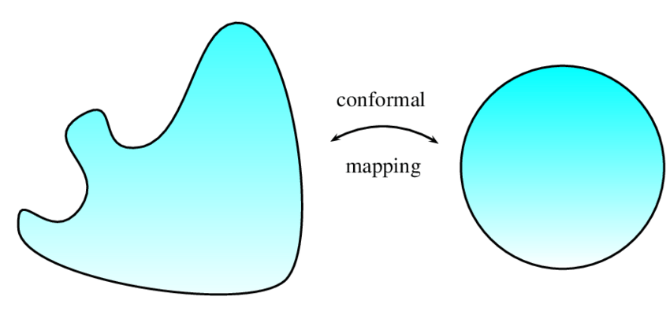
Method – This function $f\left(z\right)$ contains three arbitrary real constants which can be determined by making the center of $C'$ correspond to some given point in $R$, while some point on $C'$ to a given point on $C$.
Riemann’s mapping theorem is an existence proof, and therefore does not produce a method for deducing the desired function.
If we superimpose the $z$ plane with the $w$ plane, the transformation $w=f\left(z\right)$ maps points on the plain to points on the plane. Any points that remained unmoved under the transformation are called fixed points or invariant points.

Examples of fixed points
For the transformation $w=z^{2}$ the fixed points are found by solving $z^{2}=z$, i.e., 0 and 1.
For
$$w=\frac{2z-5}{z+4}, we solve z=\frac{2z-5}{z+4}$$
to obtain $z^{2}+2z+5=0$ with solutions (fixed points) $-1±2i$.

Some general transformations

Translations $w=z+β$

Rotation $w=e^{iθ_{0}}$

Stretching $w=az$

Inversion $w=1/z$

Successive transformations
If $w=f_{1}\left(z\right)$ maps a region of $R_{ζ}$ of the $ζ$ plane into region $R_{w}$ of the $w$ plane while $ζ=f_{2}\left(z\right)$ maps region $R_{z}$ of the $z$ plane into region $R_{ζ}$, then $w=f_{1}\left[f_{2}\left(z\right)\right]$ maps $R_{z}$ into $R_{w}$.

Linear Transformation
$$w=αz+β,$$
with $α,β$ constants. We can write this transformation in terms of successive transformations $w=ζ+β, ζ=ατ$ where $α=e^{iθ_{0}}$. A general linear transformation is a combination of translation, rotation, and stretching.

Möbius transformations or Bilinear or Fractional Transformations
$$w=\frac{αz+β}{γz+δ}, αδ-βγ≠0$$
This bilinear (or fractional transformation) can be considered as combinations of the transformations of translation, rotation, stretching, and inversion.
A bilinear transformation has the property that circles in the $z$ plane are mapped into circles in the $w$ plane, one of which may be at infinity.

Cross ratio
If $z_{1},z_{2},z_{3},z_{4}$ are distinct, then the quantity
$$\frac{\left(z_{4}-z_{1}\right)\left(z_{2}-z_{3}\right)}{\left(z_{2}-z_{1}\right)\left(z_{4}-z_{3}\right)}$$
is called the cross ratio of $z_{1},z_{2},z_{3},z_{4}$. This ratio is invariant under bilinear transformation, and this property can be used in obtaining specific bilinear transformations mapping three points in three other points. This result is derived in Method 2 in the example immediately below.

Example of application of cross ratio
Find a bilinear transformation which maps points $z=0,-i,-1$ into $w=i,1,0$, respectively.
Method 1. Since
$$w=\frac{αz+β}{γz+δ},$$
$$i=\frac{α\left(0\right)+β}{γ\left(0\right)+δ}, 1=\frac{α\left(-i\right)+β}{γ\left(-i\right)+δ}, 0=\frac{α\left(-1\right)+β}{γ\left(-1\right)+δ}.$$
The last equations tells us that $α=β.$ The first equation tells us that $δ=β/i=-iα.$ The middle equation tells us that $δ=iα.$
Method 2 – Beautiful!
If $w_{k}$ corresponds to $z_{k}$, $k=1,2,3$, we have
$$w-w_{k}=\frac{αz+β}{γz+δ}-\frac{αz_{k}+β}{γz_{k}+δ}=\frac{\left(αδ-βγ\right)\left(z-z_{k}\right)}{\left(γz+δ\right)\left(γz_{k}+δ\right)}.$$
Then
$$w-w_{1}=\frac{\left(αδ-βγ\right)\left(z-z_{1}\right)}{\left(γz+δ\right)\left(γz_{1}+δ\right)}, w-w_{3}=\frac{\left(αδ-βγ\right)\left(z-z_{3}\right)}{\left(γz+δ\right)\left(γz_{3}+δ\right)} (i).$$
Replace $w$ with $w_{2}$ and $z$ with $z_{2}$ to obtain
$$w_{2}-w_{1}=\frac{\left(αδ-βγ\right)\left(z_{2}-z_{1}\right)}{\left(γz+δ\right)\left(γz_{1}+δ\right)}, w_{2}-w_{3}=\frac{\left(αδ-βγ\right)\left(z_{2}-z_{3}\right)}{\left(γz+δ\right)\left(γz_{3}+δ\right)} (ii).$$
If $αδ-βγ≠0$ then divide $\left(i\right)$equation by $\left(ii\right)$to obtain:
$$\frac{\left(w-w_{1}\right)\left(w_{2}-w_{3}\right)}{\left(w-w_{3}\right)\left(w_{2}-w_{1}\right)}=\frac{\left(z-z_{1}\right)\left(z_{2}-z_{3}\right)}{\left(z_{2}-z_{1}\right)\left(z-z_{3}\right)},$$
the cross ratio! So, we have
$$\frac{\left(w-i\right)\left(1-0\right)}{\left(w-0\right)\left(1-i\right)}=\frac{\left(z-0\right)\left(-i+1\right)}{\left(z+1\right)\left(-i-0\right)}.$$
Solving yields
$$w=-i\left(\frac{z+1}{z-1}\right),$$
our bilinear transformation. Fixed points (and there are at most two) can be found by setting $w$ to $z$ and extracting roots:
$$iz\left(z-1\right)=iz^{2}-iz≔z+1.$$
Thus $z^{2}-z-iz-i=z^{2}-\left(1+i\right)z-i=0.$ Topologically, the fact that (non-identity) Möbius transformations fix two points (with multiplicity) corresponds to the Euler characteristic of the sphere being 2. The proof of this is non-trivial.

Möbius transformations and deeper mathematics
Möbius transformations are defined on the extended complex plane, which is the complex plane adjoined with infinity. Stereographic projection identifies the complex plane with a sphere called the Riemann sphere. (The complex plane can also be thought of as the complex projective line.) These beautiful transformations make contact with projective geometry and algebraic geometry. How quickly mathematical constructs ramify is head spinning.

Mobius transformations and Quantum Field Theory
Finally, the group of Möbius transformations is isomorphic to the Lorentz group, tying it deeply to relativistic quantum physics as developed in detail in Quantum Field Theory, 2nd ed by Lewis W. Ryder. The Lorentz group can be thought of as two copies of $SU\left(2\right)$, and $SU\left(2\right)$ (with -$SU\left(2\right)$) have a two-to-one correspondence to the group of rotations in three dimensions which preserve length, often called the orthogonal group $O\left(3\right)$. The orthogonal group in dimension $n$ has two connected components. The one that contains the identity element is a subgroup, called the special orthogonal group, and denoted $SO\left(n\right)$. It consists of all orthogonal matrices of determinant 1. $SO\left(3\right)$ preserves lengths and orientation, making it the group of rotations in classical physics.
The connection between seemingly straightforward Möbius transformations and the Lorentz group is not obvious until written down. Consider two-by-two invertible matrices with complex-valued elements.
$$f\left(z\right)=\frac{az+b}{cz+d}=\left[z,1\right]\left(\begin{matrix}a & c \\ b & d\end{matrix}\right)=\left[az+b, cz+d\right]=\left[\frac{az+b}{cz+d},1\right]$$
where the last term is in projective coordinates. (Projective coordinates are usually triples, e.g., $\left(x,y,z\right)$ but with $z≠0$ they project onto the Euclidean plane, and we write: $\left(x/z,y/z,1\right)$, or simply $\left(x/z,y/z\right).$Moreover, unlike Cartesian coordinates, a single point can be represented by infinitely many homogeneous coordinates. Möbius initially developed projective coordinates as barycentric coordinates of great use in video games graphics, physics, and simplicial homology in algebraic topology.
If the two-by-two matrices have determinant 1, the matrices are unitary, that is $UU^{*}=U^{*}U=I$, (in physics notation: $UU^{†}=U^{†}U=I,$ where $U^{†}$ is the Hermitian adjoint). Th matrices operate on spinors in non-relativistic quantum mechanics with group $SU\left(2\right),$ and in relativistic quantum physics, the Lorentz group is given by $SU\left(2\right)⊗SU\left(2\right)$ operating on quaternions representing the spin up and down states of electrons and their antimatter twins: positrons discovered by Dirac and studied by Wigner.
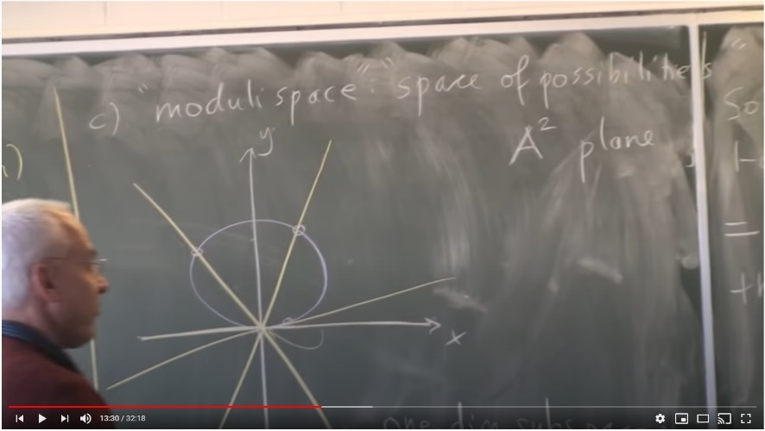
If one considers the set of all lines passing through the origin of a plane with Cartesian coordinates as one-dimensional vector spaces, then the set of these vector spaces is topologically equivalent to a circle. This is the idea of the real projective line. This is explained beautifully at the end of Norman Wildberger’s first lecture (after the introductory lecture) in an introductory course in algebraic topology:
The real projective line is an extension of the usual concept of line that has been historically introduced to solve a problem set to visual perspective: two parallel lines do not intersect but seem to intersect "at infinity" (or at the horizon). At the horizon, we add infinity to the real projective line.
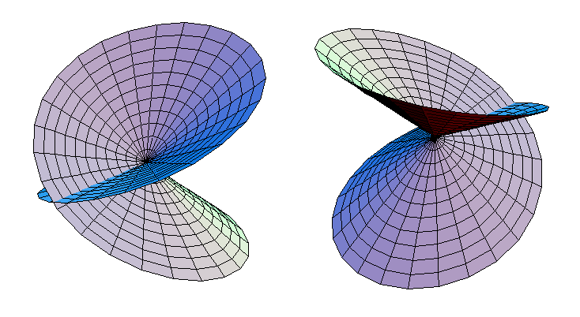
If one identifies points on the right hand side of the circle (the real projective line) with points across the diameter on the other side of the circle, we construct the projective plane. The fundamental group of the projective plane is isomorphic to $Z_{2}$, or addition modulo 2. The fundamental group is the first and simplest homotopy group. Use Google to search for images or videos of the real projective plane:
Moving the above concepts to the complex plane we get the complex projective line which can be shown to be topologically equivalent to the Riemann sphere.
The seemingly illimitable digressions mathematicians traverse away from physics is why I restrict myself to the mathematics of possible physical universes, e.g., for hyperspheres, no other hyperspheres than $S1, S3, S7$ are physical. This is different than the possibility that some seemingly purely mathematical digression doesn’t turn up to have meaning within the physics of our universe or some other universe, e.g., fiber bundle theory. This is already a lot of work:
For those like me who believe that understanding means tracking and pinning down every detail, say, how Lorentz or Poincare transformations affect spinors, one can start with Quantum Field Theory, second edition, Lewis H. Ryder, but to this end he will lead you to High Energy Physics, Les Houches 1965, specifically the course notes from F. Gürsey.

Mapping of a half-plane on to a circle
Let $z_{0}$ be a point $P$ in the upper half-plane of the $z$ plane, $R,$ in the figure above. The transformation
$z$ plane
R
B
A
D
C
E
F
x
y
v
u
A’
B’
E’
F’
C’
D’
$$θ_{0}$$
$$1$$
P’
P’
$$z_{0}$$
R’
$w$ plane
$$w=e^{iθ_{0}}\left(\frac{z-z_{0}}{z-\overline{z{}_{0}}}\right)$$
maps the upper half-plane in a one-to-one manner on to the interior of $R'$ of the unit circle $\left|w\right|=1$, and conversely. Each point of the $x$ axis is mapped on to the boundary of the circle. The constant $θ_{0}$ can be determined by making one particular point of the $x$ axis correspond to a given point on the circle.

Example of mapping a half-plane on to a circle
Find a bilinear transformation which maps the upper half of the $z$ plane into the unit circle in the $w$ plane in such a way that $z=i$ is mapped into $w=0$ while the point at infinity is mapped into $w=-1$.
We have $w=0$ corresponding to $z=i$ and $w=-1$ corresponding to $z=∞$. Then from
$z$ plane
R
B
A
D
C
E
x
y
v
u
A’
B’
E’
C’
D’
$$1$$
P’
P’
$$i$$
R’
$w$ plane
$$w=e^{iθ_{0}}\left(\frac{z-z_{0}}{z-\overline{z{}_{0}}}\right)$$
we have
$$0=e^{iθ_{0}}\left(\frac{i-z_{0}}{i-\overline{z{}_{0}}}\right)$$
so that $z_{0}=i$. Corresponding to $z=∞$, we have $w=e^{iθ_{0}}=-1$. Hence the sought out transformation is
$$w=\left(-1\right)\left(\frac{z-i}{z+i}\right)=\frac{i-z}{i+z}.$$
Appendix 2 contains a table of conformal maps.

Physical application of conformal mapping

Boundary value problems
A partial differential equation which satisfies boundary conditions is called a boundary value problem.

Harmonic and Conjugate functions
A harmonic function in a region $R$ satisfies Laplace’s equation: $∇^{2}ϕ={∂^{2}ϕ}/{∂x^{2}+}{∂^{2}ϕ}/{∂y^{2}}=0.$ We have already seen that if $f\left(z\right)=u\left(x,y\right)+iv\left(x,y\right)$ is analytic in $R$, then $u$ and $v$ are harmonic, and called conjugate functions.

Dirichlet and Neumann problems
Let $R$ be a simply-connected region bounded by a simple closed curve $C$. Two types of boundary-value problems are of great importance:

Dirichlet’s problem
Dirichlet’s problem seeks a function $ϕ$ satisfying Laplace’s equation in $R$ and takes prescribed boundary values on the boundary $C$.

Neumann’s problem
Neumann’s problem seeks a function $ϕ$ satisfying Laplace’s equation in $R$ and whose normal derivative ${∂ϕ}/{∂n}$ takes prescribed values on the boundary $C$.

Dirichlet problem for the Unit Circle – Poisson’s formula for the circle
Let $C$ by the unit circle $z=\left|1\right|$ and $R$ be its interior. A function which satisfies Laplace’s equation at each point $\left(r,θ\right)$ in $R$ and takes on the prescribed value $F\left(θ\right)$ on $C$ [i.e., $ϕ\left(1,θ\right)=F\left(θ\right)$], is given by
$$\frac{1}{2π}\int_{0}^{2π}{\frac{\left(1-r^{2}\right)F\left(ϕ\right)}{1-24\cos\left(θ-ϕ\right)+r^{2}}dϕ.}$$

The Dirichlet problem for the half-plane – Poisson’s formula for the half-plane
A function which is harmonic in the upper half-plane $y>0$ [ Im$\left\{z\right\}>0$] and which takes the value $G\left(x\right)$ on the $x$ axis [i.e., $ϕ\left(x,0\right)=G\left(x\right), -∞<x<∞$], is given by
$$ϕ\left(x,y\right)=\frac{1}{π}\int_{-∞}^{∞}{\frac{yG\left(η\right)}{y^{2}+{\left(x-η\right)}^{2}}dη}.$$

‘Chicken-egg’ potential problems between the unit circle and half-plane problems
There is the boundary-value problem of determining a potential function for the upper half-plane by two methods: Poisson’s formula for the half-plane and by clever usage of polar coordinates. The ‘inverse’ boundary-value potential problem is determining the potential function on a unit circle by two methods: Poisson’s integral formula for the circle, or conformal mapping from the unit circle in the $z$ plane to the upper half-plane in the $w$ plane. Really, the two problems are chicken-egg problems.

Chicken problem for $∇^{2}ϕ=0$ as specified by the figure below
Consider the upper half-plane below with boundary values for the potential function $ϕ$
$$ϕ=1$$
$$ϕ=0$$
x
y
$$\left(x,y\right)$$
r
$$θ$$
We must solve
$$\frac{∂^{2}ϕ}{∂x^{2}}+\frac{∂^{2}ϕ}{∂y^{2}}=0, y>0, \lim_{y→0+}{ϕ\left(x,y\right)}=G\left(x\right)=\left\{\begin{matrix}1, x>0 \\ 0, x<0\end{matrix}\right\}.$$

Chicken Method 1-Using Poisson’s formula for the half-plane
$$ϕ\left(x,y\right)=\frac{1}{π}\int_{-∞}^{∞}{\frac{yG\left(η\right)}{y^{2}+{\left(x-η\right)}^{2}}dη} \\ =\frac{1}{π}\int_{0}^{∞}{\frac{1∙y}{y^{2}+{\left(x-η\right)}^{2}}dη} \\ =1-\frac{1}{π}\tan^{-1}{\frac{y}{x}},$$
which we shall convert back to polar coordinates after method two (which gives the same answer).

Chicken Method 2 – using polar coordinates
With $x=r\cos{θ}$ and $y=r\sin{θ},$ by clever observation, consider the following analytic (and hence harmonic function)
$$A\ln{z}+B=A\ln{re^{iθ}}+B=A\ln{r}+iA\left(θ+2nπ\right), n=1,2,3,…, A,B=real constants$$
The imaginary part, $Aθ+B$ is harmonic.
To determine $A$ and $B$ note that the boundary conditions are $ϕ=1$ for $x>0,$ i.e., $θ=0$and $ϕ=0$ for $x<0$, i.e., $θ=π$. That is $1=A∙0+B, 0=A∙π+B.$ We have $A=-1/π$ and $B=1$. So
$$ϕ=1-\frac{θ}{π}=1-\frac{1}{π}\tan^{-1}{\frac{y}{x}},$$
the same solution we got from Method 1 above.

Egg problem for $∇^{2}ϕ=0$ on the unit circle
Find a function harmonic inside the unit circle $z=\left|1\right|$and taking the prescribed values given by
$$F\left(θ\right)=\left\{\begin{matrix}1, 0<θ<π \\ 0, π<θ<2π\end{matrix}\right\}.$$

Method 1 – Using Poisson’s formula for the unit circle
$w$ plane
B’
A’
D’
C’
E’
u
v
$$ϕ=1$$
$$ϕ=0$$
y
x
A
B
E
C
D
$z$ plane
$$ϕ=0$$
$$ϕ=1$$
$$ϕ\left(r,θ\right)=\frac{1}{2π}\int_{0}^{2π}{\frac{F\left(ϕ\right)}{1-2r\cos\left(θ-ϕ\right)+r^{2}}}dϕ \\ =\frac{1}{2π}\int_{0}^{π}{\frac{1}{1-2r\cos\left(θ-ϕ\right)+r^{2}}}dϕ=1-\frac{1}{π}\tan^{-1}\left(\frac{2r\sin{θ}}{1-r^{2}}\right).$$

Method 2 – Conformal mapping
A few sections ago we did a conformal mapping of the upper half-plane in the $z$ plane on to the unit circle in the $w$ plane. Here, we map the interior of the circle $z=\left|1\right|$, where our potential problem is defined, on to the upper half-plane of the $w$ plane by ‘inverting’ the mapping from the unit circle in the $z$ plane to the upper half-plane in the $w$ plane:
$$w=\frac{i-z}{i+z}⟼z=\frac{i-w}{i+w}.$$
Under this transformation, arcs $ABC$ and $CDE$ are mapped to the negative and positive real axis $A'B'C'$ and $C'D'E'$ respectively of the $w$ plane.
$w$ plane
B’
A’
D’
C’
E’
u
v
$$ϕ=1$$
$$ϕ=0$$
y
x
A
B
E
C
D
$z$ plane
$$ϕ=0$$
$$ϕ=1$$
The boundary conditions on the unit circle in the $z$ plane get mapped to the boundary conditions in upper half-plane in the $w$ plane. We must solve
$$\frac{∂^{2}ϕ}{∂x^{2}}+\frac{∂^{2}ϕ}{∂y^{2}}=0, y>0, \lim_{y→0+}{ϕ\left(x,y\right)}=G\left(x\right)=\left\{\begin{matrix}1, x>0 \\ 0, x<0\end{matrix}\right\}.$$
The ‘Egg’ problem has become the ‘Chicken’ problem! So the solution in the chicken problem maps to the solution in the egg problem:
$$ϕ=1-\frac{θ}{π}=1-\frac{1}{π}\tan^{-1}{\frac{y}{x}}⟼ϕ=1-\frac{1}{π}\tan^{-1}{\frac{u}{v}}$$
From
$$w=\frac{i-z}{i+z}$$
we get real and imaginary parts of $w$ as:
$$u=\frac{1-\left(x^{2}+y^{2}\right)}{\left(1+x^{2}\right)+y^{2}}, v=\frac{2y}{\left(1+x^{2}\right)+y^{2}}.$$
Hence
$$ϕ=1-\frac{1}{π}\tan^{-1}{\frac{2y}{1-\left(x^{2}+yy^{2}\right)}.}$$
With $x=r\cos{θ}$ and $y=r\sin{θ}$, we get
$$ϕ=1-\frac{1}{π}\tan^{-1}\left(\frac{2r\sin{θ}}{1-r^{2}}\right).$$
We can clearly do the egg problem first and then do the chicken problem – hence the chicken-egg problem.

Schwartz-Christoffel Transformation
Consider the problem of the polygon in the $w$ plane having vertices $w_{1},w_{2},w_{3},…,w_{n}$ with corresponding interior angels $α_{1},α_{2},α_{3},…,α_{n}$ respectively. Let the points $w_{1},w_{2},w_{3},…,w_{n}$ map respectively to $x_{1},x_{2},x_{3},…,x_{n}$ on the real axis of the $z$ plane.
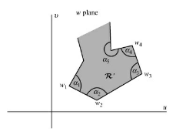
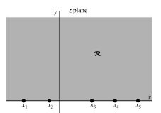
A transformation which maps the interior $R$ of the polygon of the $w$ plane on to the upper half $R'$ of the $z$ plane and the boundary of the polygon on to the real axis is given by
$$\frac{dw}{dz}=A{\left(z-x_{1}\right)}^{\left({α_{1}}/π-1\right)}{\left(z-x_{2}\right)}^{\left({α_{2}}/π-1\right)}⋯{\left(z-x_{n}\right)}^{\left({α_{n}}/π-1\right)}$$
or
$$w=A\int{{\left(z-x_{1}\right)}^{\left({α_{1}}/π-1\right)}{\left(z-x_{2}\right)}^{\left({α_{2}}/π-1\right)}⋯{\left(z-x_{n}\right)}^{\left({α_{n}}/π-1\right)}}dz+B$$
where $A$ and $B$ are complex constants. The following should be noted:
- Any three of the points $x_{1},x_{2},x_{3},…,x_{n}$ can be chosen at will.
- The constants A and B determine the size, orientation, and position of the polygon.
- It is convenient to choose one point, say, $x_{n}$, at infinity, in which case the last factor of our differential above, or the integral equation below, involving $x_{n}$ is not present.
- Infinite open polygons can be considered as limiting cases of closed polygons.
For a closed polygon, we may show that the sum of the exponents is equal to -2, the Euler characteristic. We know that the sum of the interior angles of a closed polygon is $2π$. Then
$$\left(π-α_{1}\right)+\left(π-α_{2}\right)+…+\left(π-α_{n}\right)=2π$$
and dividing by $-π$, we obtain as required
$$\left(\frac{π}{α_{1}}-1\right)+\left(\frac{π}{α_{2}}-1\right)+…+\left(\frac{π}{α_{n}}-1\right)=-2.$$
Christoffel completed his doctoral degree in 1856 and in 1862 succeeded Dedekind as a professor of mathematics at the Swiss Federal Institute of Technology in Zurich. It was in Zurich that he published the first paper on the Schwarz–Christoffel formula. Christoffel’s motivation was the problem of heat conduction, which he approached by means of the Green’s function. This paper presented the discovery that, in the case of a polygonal domain, the Green’s function could be obtained via a conformal map from the half-plane. Hermann Amandus Schwarz (1843–1921) grew up nearly a generation after Christoffel but also very much under the influence of Riemann. In the late 1860s he was living in Halle, where his discovery of the Schwarz–Christoffel formula apparently came independently of Christoffel’s. Both of them were heavily influenced by the work of Riemann when they did their work on conformal maps.
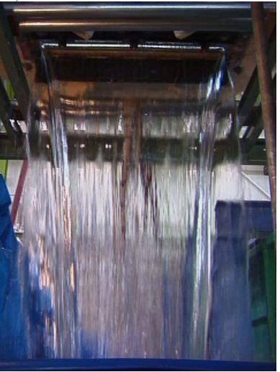
Virtually all conformal transformations whose analytic forms are known are Schwarz–Christoffel maps, albeit sometimes disguised by an additional change of variables. In the majority of practical problems, there is no analytic solution for the prevertices, which depend nonlinearly on the side lengths of. Numerical computation is also usually needed to evaluate the integral above and to invert the map. Thus, much of the potential of SC mapping went unrealized until computers became readily available in the last quarter of the twentieth century. The paper in this link applies the Schwarz-Christoffel transformation to problem of fluid flow through a two-dimensional rectangular orifice.

Transformations of Boundaries in Parametric Form
Suppose that in the $z$ plane a curve $C$, which may or may not be closed, has parametric equations given by
$$x=F\left(t\right), y=G\left(t\right)$$
where we assume that $F$ and $G$ are continuously differentiable. Then the transformation $z=F\left(w\right)+iG\left(w\right)$ maps the curve $C$ on to the real axis $C'$ of the $w$ plane.

Appendix 1 – The usual functions but in complex variables

Logarithmic Functions
If $z=e^{w}$, then we write $w=\ln{z},$ called the natural logarithm of $z$. Thus the natural logarithm is the inverse of the exponential function and can be defined by
$$w=\ln{z}=\ln{r}+i\left(θ+2kπ\right), k=0,±1,±2,…$$
where $z=re^{iθ}=re^{i\left(θ+2kπ\right)}.$ Note that $\ln{z}$ is a multiple-valued function (infinitely valued in this case). The principle value or principle brand of $\ln{z}$ is sometimes defined as $\ln{r}+iθ$ where $0≤θ≤2π$. However, any other interval of length 2 can be used, e.g., $-π<θ<π$, etc.

Inverse Trigonometric Functions
If $z=\sin{w}$, then $w=\sin^{-1}{z}$ is called the inverse arcsine of $z$ or arc sine of $z.$ Similarly, we define other inverse trigonometric or circular functions $\cos^{-1}{z},\tan^{-1}{z}$, etc. These functions are multivalued and can be expressed in terms of natural logarithms as follows. In all cases the additive constant $2πki, k=0,±1,±2,…,$ seen in the logarithm above.
$$\sin^{-1}{z=\frac{1}{i}\ln\left(iz+\sqrt{1-z^{2}}\right)}, \csc^{-1}{z}=\frac{1}{i}\ln\left(\frac{i+\sqrt{z^{2}-1}}{z}\right)$$
$$\cos^{-1}{z}=\frac{1}{i}\ln\left(z+\sqrt{z^{2}-1}\right), \sec^{-1}{z}=\frac{1}{i}\ln\left(\frac{1+\sqrt{1-z^{2}}}{z}\right)$$
$$\tan^{-1}{z}=\frac{1}{2i}\ln\left(\frac{1+iz}{1-iz }\right), \cot^{-1}{z}=\frac{1}{2i}\ln\left(\frac{z+i}{z-i}\right)$$

Inverse Hyperbolic Functions
If $z=\sinh{w}$ then $w=\sinh^{-1}{z}$ is called the inverse hyperbolic sine of $z$ or arc sin of $z$. These functions, which are multivalued, can be expressed in terms of natural logarithms as follows. In all cases the additive constant $2πki, k=0,±1,±2,…,$ seen in the logarithm above.
$$\sinh^{-1}{z}=\ln\left(z+\sqrt{z^{2}+1}\right), {csch}^{-1}\left(z\right)=\ln\left(\frac{1+\sqrt{z^{2}+1}}{z}\right)$$
$$\cosh^{-1}{z}=\ln\left(z+\sqrt{z^{2}-1}\right), \sec^{-1}{z}=\left(\frac{1+\sqrt{1-z^{2}}}{z}\right)$$
$$\tanh^{-1}{z}=\frac{1}{2}\ln\left(\frac{1+z}{1-z}\right), \cot^{-1}{z}=\frac{1}{2}\ln\left(\frac{z+1}{z-1}\right)$$

The Function $z^{α}$, $α$ possibly complex is defined by $e^{α\ln{z}}$.
Similarly if $f\left(z\right)$ and $g〈z〉$ are two given functions of $z$, we can define $f{\left(z\right)}^{g\left(z\right)}=e^{g\left(z\right)\ln{z}}$. Generally, these types of functions are multi-valued.
This would be a great time tor review Branch points and Branch lines.

Appendix 2 – Schaum’s Outline Series – Theory and Problems of Complex Variables, 1993
IMPORTANT for all conformal mappings in this appendix. If you specify the boundary-value problem on the boundary of the infinite sector, and map it to the upper half plane in the $w$ axis, on can use Poisson’s formula for the upper half-plane to find a harmonic potential function that satisfies Laplace’s equation $∇^{2}ϕ=0.$ This applies to all of the following conformal maps.

Sample mappings onto/on the upper half-plane

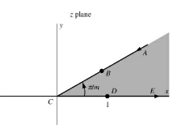
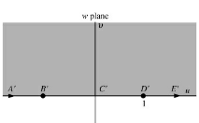
Infinite sector of angle $π=m$ – For $m>1/2$, let $w=z^{m}$

Say $m=4$ and $A=\left(1,1\right).$ Then $w={\left(1+i\right)}^{4}=-4=A'$. Say $B=\left(1/2,1/2\right)$, then $w=-1/4=B'$. Say $C=\left(0,0\right)$. Then $w=\left(0,0\right)=C'$. Say $D=\left(1,0\right)$. Then $w=\left(1,0\right)=D'$.

Infinite strip of width $a$ – Let $w=e^{{πz}/a}$
Say $B=\left(0,a\right)$. Then $w=e^{{π\left(0+ia\right)}/a}=e^{iπ}=\cos{π+i}\sin{π}=-1.$
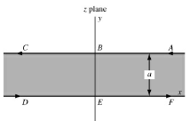
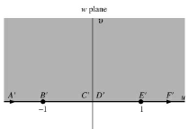

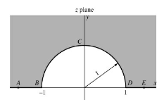
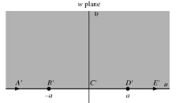
Half plane with semicircle removed – Let $w=a/2\left(z+1/z\right)$.

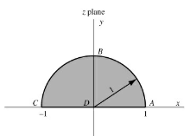
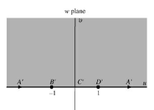
Semicircle – Let $w={\left({\left(1+z\right)}/{\left(1-z\right)}\right)}^{2}$.

Sector of a circle – Let $w={\left({\left(1+z^{m}\right)}/{\left(1-z^{m}\right)}\right)}^{2}$.
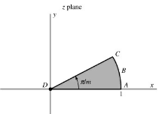
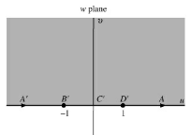

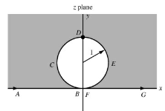
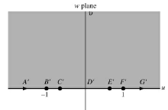
Half-plane with a circle removed – Let $w=\coth\left(π/z\right).$

Semi-infinite strip of width $a$ case 1 – Let $w=\sin{{πz}/a}.$
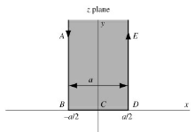
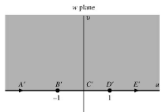

Semi-infinite strip of width $a$ case 2 – Let $w=\cos{{πz}/a}.$
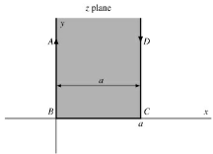
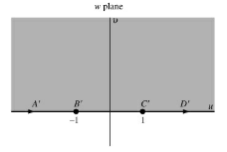

Semi-infinite strip of width $a$ case 3 – Let $w=\cos{{πz}/a}$.
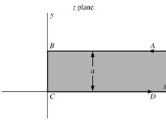
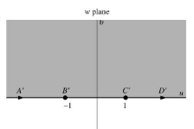

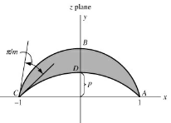
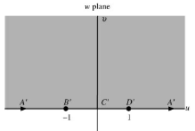
Lens-shaped region of angle $π/m$, the arcs are circular – Let $w=e^{2mi\cot^{-1}{p}}{\left(\frac{z+1}{z-1}\right)}^{m}, m≥2$

Exterior of a parabola $y^{2}=4p\left(p-x\right)-$Let $w=i\left(\sqrt{z}-\sqrt{p}\right)$
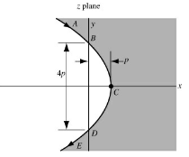
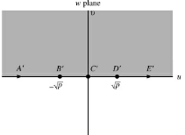

Interior of a parabola $y^{2}=4p\left(p-x\right)$ – Let $w=e^{πi\sqrt{z/p}}$
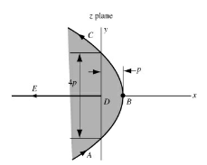
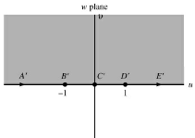

Channel with right angle – Let $w=2/π\left\{\tanh^{-1}{p\sqrt{z}}-p\tan^{-1}{\sqrt{z}}\right\}$
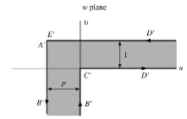
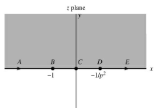

Interior of the triangle – Let $w=\int_{0}^{∞}{t^{α/π-1}{\left(1-t\right)}^{β/π-1}dt }$

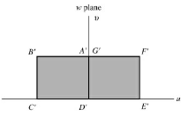
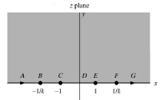
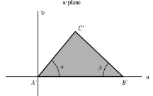
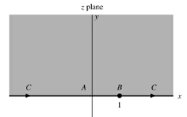
Interior of a rectangle – Let $w=\int_{0}^{z}{\frac{dt}{\sqrt{\left(1-t^{2}\right)\left(1-k^{2}t^{2}\right)}}}$

Plane with two semi-infinite cuts – Let $w=-πi+2\ln{z}-z^{2}$
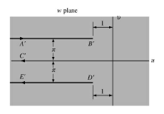
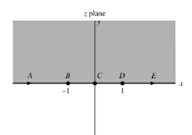

Sample mappings on/onto unit circle

Exterior of unit circle of radius 1 – Let $w=1/z.$
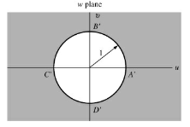
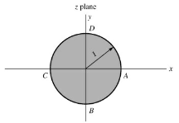

Exterior of the ellipse – Let $w=1/2\left(ze^{-α}+z^{-1}e^{α}\right).$
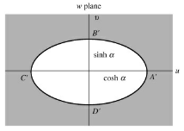
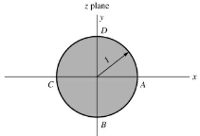

Exterior of parabola $y^{2}=4p\left(p-x\right)$ – Let $w=2\sqrt{p/z}-1$
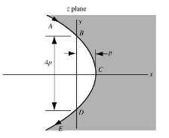
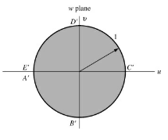

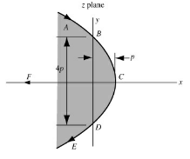
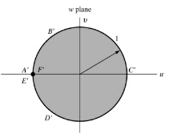
Interior of parabola $y^{2}=4p\left(p-x\right)$ – Let $w=\tan^{2}{\frac{π}{4}\sqrt{\frac{z}{p}}}$

Miscellaneous

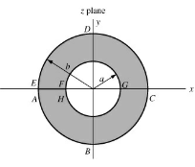
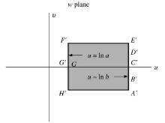
Annulus onto a rectangle – Let $w=\ln{z}.$

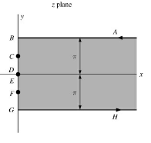
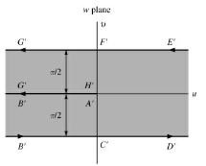
Semi-infinite strip on to infinite strip – Let $w=\ln{\coth{z/2}}$

Semi-infinite strip of width $a$ on to a quarter plane – Let $w=\sin{{πz}/{2a}}$
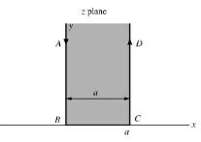
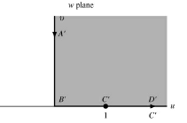

Interior of cardioid on to a circle $ρ=2a^{2}\left(1+\cos{ϕ}\right)$ – Let $w=z^{2}$
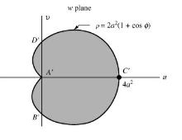
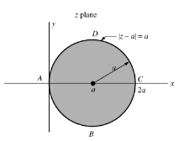

Plane with two semi-infinite cuts on to infinite strip
